Name:  Group:  Date :

COMPLEMENTARY ACTIVITIES Worksheet 2.2



**Complementary activities (Issue: *Consuming Goods and Services*)**

**Chapter 2 Advertising: Decoding the Message**

► *Textbook, pp.28–39*

1. What are the main goals of advertising?

1. Indicate the goal of each of the following advertisements.

1. A consumer might purchase earbuds to use with a computer, a tablet or a smart phone. To further enhance the sonic experience, a company offers high-end headsets.
2. For a sports equipment company, an advertising agency organizes an extreme sporting event, promoting perseverance, performance and self-improvement.
3. In an advertisement for a brand of yogourt, a doctor explains how adding certain bacteria to the product is beneficial for the immune system.
4. A government advertisement shows a group of young adults who, before going to a party, discuss which one of them will be the designated driver.

1. For each of the following situations, identify the goal of the advertisement and the advertising  
   strategy.
   1. An advertisement for a smart phone depicts individuals between the ages of 18 and 35  
      wearing trendy clothes and using the phone in a variety of everyday situations.

Goal:

Strategy:

* 1. A brand of sportswear hires a basketball player to use his fame to spread the word about the unifying power of sports.

Goal:

Strategy:

Name:  Group:  Date :

COMPLEMENTARY ACTIVITIES (*cont.*) Worksheet 2.2



* 1. In an advertisement for an energy drink, a company would like to emphasize the product’s strengths by explaining that it can be efficient and useful for recovering after a workout. However, the negative elements associated with the consumption of the beverage are not mentioned.

Goal:

Strategy:

1. In each case, indicate the advertising goal, provide a short description of the image and identify the tagline and logo.

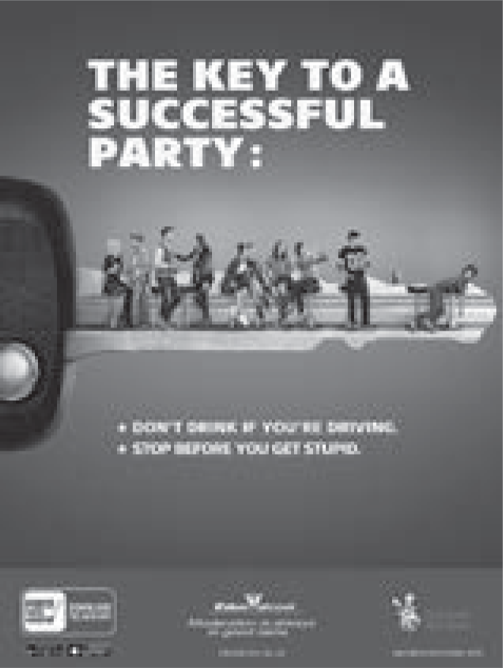

Goal:

Image:

Tagline:

Logo:

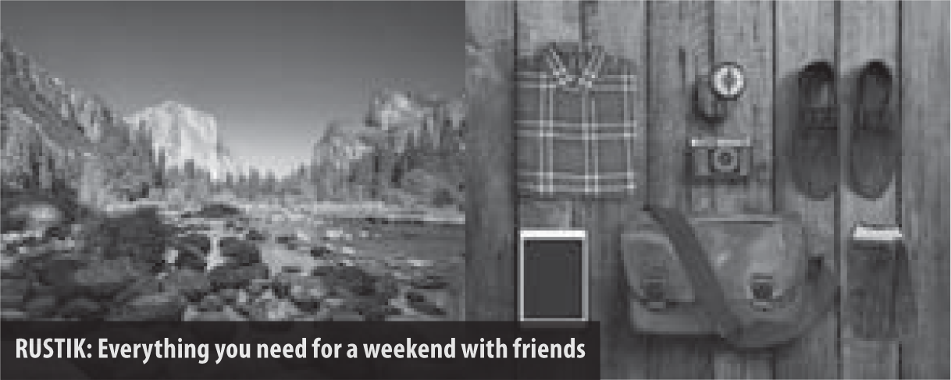

Goal:

Image:

Tagline:

Logo:

Name:  Group:  Date :

COMPLEMENTARY ACTIVITIES (*cont.*) Worksheet 2.2



1. Which law protects the rights of consumers and establishes guidelines for the commercial  
   practices of companies?

1. Are the following statements true or false? If you indicate that a statement is false, correct it.

|  |  |  |
| --- | --- | --- |
| **Statement** | **True** | **False** |
| 1. An advertisement can be directed at parents, for example, when a brand of cereal promotes nutritional properties necessary for child development. |  |  |
| 1. A brand of soap can make a favourable comparison between its products and other well-known brands without naming them. |  |  |
| 1. A manufacturer can focus exclusively on the positive features of its products, without explicitly lying. |  |  |
| 1. A merchant can create a contest without divulging the number of prizes that can be won. |  |  |
| 1. After selling out of a particular sale item, a merchant must provide a rain check to any consumer who would like to buy the item. |  |  |
| 1. An advertisement can claim that the purchase of an article of clothing actually represents a monetary benefit, because the item costs more elsewhere. |  |  |
| 1. A company can use an artist’s music without securing the rights if the artist is well-known. |  |  |
| 1. A department store can put a label with the sale price of an item on top of the regular price. |  |  |
| 1. A merchant can stop selling an item on sale earlier than announced if the quantity is exhausted. |  |  |

**Corrections:**

Name:  Group:  Date :

COMPLEMENTARY ACTIVITIES (*cont.*) Worksheet 2.2



1. Indicate which law is not being respected in each of the following cases.
   1. For some time, Tristan has been receiving a large quantity of online advertising from a  
      performance venue. No one asked him for his consent before sending the advertisements.

* 1. Audrey agreed to a company’s offer of Internet services as a result of a phone call from a telemarketer. However, after reading the contract, she notices that the company’s written offer is different from and less desirable than the offer made over the phone.

1. Why is advertising targeted to children prohibited in Québec?

1. Why are your personal data and your online browsing habits so valuable to advertising networks?

1. **Summary** “The anti-advertising movement’s message is merely another advertisement, just like  
   commercial or government advertising.”

Do you agree or disagree with this statement? Justify your answer.