Work (The Physics Classroom)

http://www.physicsclassroom.com/class/energy
Words that can be used many ways in an English classroom have very specific meanings in a Science classroom.
So far in Physics we have utilized Newton's second law of physics to analyze the motion of objects. Force and mass information were used to determine the acceleration of an object.

Work is a ________________________ acting over a ________________________________

to cause a change in _______________________________.

There are three key ingredients to work - force, displacement, and cause. In order for a force to qualify as having done work on an object, there must be a displacement (a distance and a direction) and the force must cause the displacement.

Work is being done in the following 3 diagrams.

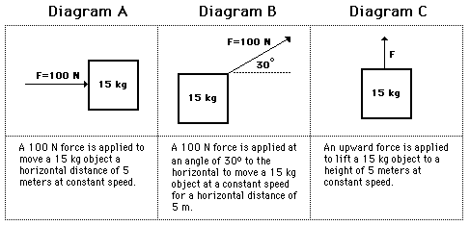

Work = ________________________ x __________________________

The force must be acting in the _____________________ ____________________________

as the _____________________________________________.

ERGO: Trig!!

Indicate whether or not the following represent examples of work:

Situation | Work done? Yes or No | Defense
A teacher applies a force to a wall and becomes exhausted.

A weightlifter lifts a barbell above her head.

A waiter carries a tray full of meals across a dining room at a constant speed.

A rolling marble hits a note card and moves it across a table.

A shot-putter launches the shot.

Solve Diagram A:

Solve Diagram C:

Trig
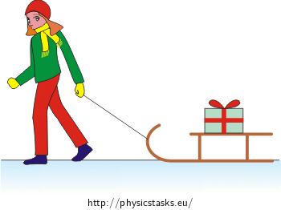

Before beginning its initial descent, a roller coaster car is always pulled up the first hill to a high initial height. Work is done on the car (usually by a chain) to achieve this initial height.
A coaster designer is considering three different angles at which to drag the 2000-kg car train to the top of the 60-meter high hill. Her big question is: which angle would require the most work?

Angle (º) | Force (N) x 10⁴ | Distance (m) | Work (kJ)
35 | 1.15 | 105.0
45 | 1.41 | 84.9
55 | 1.64 | 73.2

The Meaning of Negative Work
On occasion, a force acts upon a moving object to hinder a displacement.
Examples might include
- a car skidding to a stop on a roadway surface
- a baseball runner sliding to a stop on the infield dirt

In such instances, the force acts in the direction opposite the objects motion in order to slow it down.
The force doesn't cause the displacement but rather hinders it.
These situations involve what is commonly called negative work.
The negative of negative work refers to the numerical value that results when values of F, d and theta are substituted into the work equation.
Since the force vector is directly opposite the displacement vector, theta is 180 degrees.
The cosine (180 degrees) is -1 and so a negative value results for the amount of work done upon the object.

