Ecotoxicology

Wolves of Yellowstone
1. As you are watching, create a "bubble map" that includes all of the things that happened in the Yellowstone ecosystem in the absence of wolves. Add as many lines and bubbles from the centre bubble as needed.
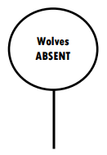

2. Create a food chain of the 3 organisms that are involved in the trophic cascade in Yellowstone.
3. Predict what would happen to the wolf and elk populations if there was a drought that caused many of the plant species to dry up and/or die.

4. With the elimination of wolves from the ecosystem, how was the population of plants (producers) indirectly affected?

5. 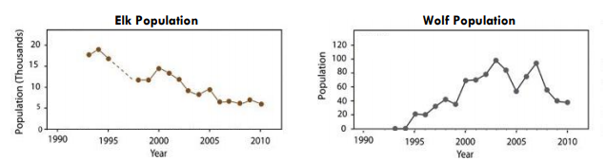
a. You have already identified that wolves are a predator of elk. Describe the general trend of the elk and wolf populations between 1993 and 2003.

b. Based on the graphs, what year do you think wolves were introduced to Yellowstone? Explain why you think this.

c. Using information from the graphs, describe what happens to the wolf and elk populations in 2005.
Indicate what you think might have happened during this year to cause this change.

d. In 2010, the wolf population was lower than in previous years. Make a prediction about the elk population in the years beyond 2010 if the wolf population continues to stay at the 2010 level.

6.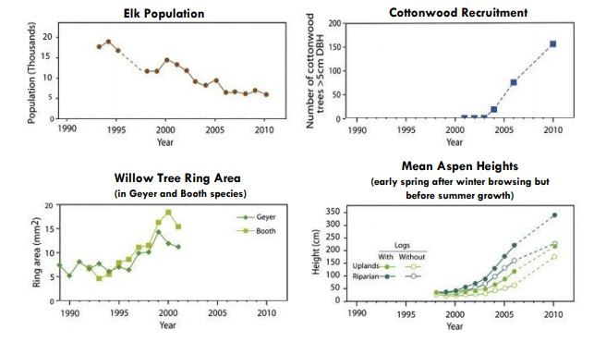
a. Define recruitment: ___________________________________________________
Define mean: ___________________________________________________
What do tree rings indicate? _____________________________________________
b. Use information from the graphs to describe the change in the size and growth of the trees and the population of elk during the data collection periods depicted in the graphs.

c. What can you infer about the relationship between elk population and tree growth?

https://d43fweuh3sg51.cloudfront.net/media/media_files/Wolves_StudentHandout_Part_1_UPLOAD.pdf

