Voltaic or Galvanic Cell
LEO says GER

Watch the demonstration and sketch the set up:

Write down the BCE for what took place:

BCE_______________________________________________________________________

IE________________________________________________________________________

NIE_______________________________________________________________________

What type of chemical reaction was taking place?

_____________________________________

In the NIE write the oxidation number over each element:

______________________________________________________________________

Which species lost electrons? ________________________

Which species gained electrons? _______________________

Which species was oxidized? _______________________

Which species was reduced? _______________________

1) Set up the above circuit from the sketch.

2) Record the voltage generated by the cell.

3) Write the equation for the reaction occurring at the NEGATIVE electrode--the ANODE in an electrochemical cell--the opposite of every other situation:

______________________________________________________________________

4) Write the equation for the reaction occurring at the POSITIVE electrode--the CATHODE in an electrochemical cell--the opposite of every other situation:

______________________________________________________________________

5) Write the equation for the overall reaction occurring:

______________________________________________________________________

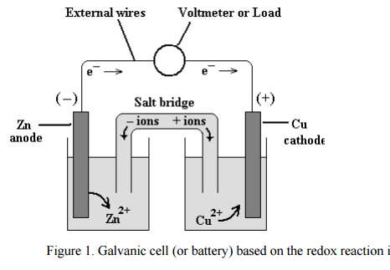

6) What is the reason for the salt bridge?

______________________________________________________________________

How does it function? ____________________________________________________

______________________________________________________________________

7) What will happen to the mass of the Zn electrode?

______________________________________________________________________

Why? _________________________________________________________________

8) What will happen to the mass of the Cu electrode?

______________________________________________________________________

Why? _________________________________________________________________

