Voltaic Cell Problems

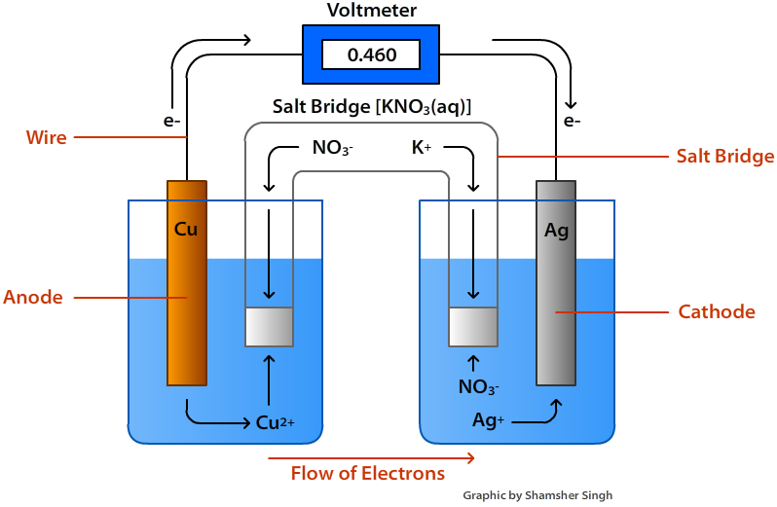

“The RED CAT gets fat.”
Calculate the potential (voltage) of a cell made using the above materials.
Remember—the more “positive” ½ reaction is the one that takes place.

A positive cell potential means the reaction is spontaneous i.e. it will occur.
1) Sketch and calculate the cell made using the following chemicals:
- Magnesium and Iron
- 1 M Magnesium nitrate and 1 M Iron (III) nitrate

Which is the more reactive metal and why?

______________________________________________________________________

2) Can I stir a gold (I) nitrate soup with an aluminum spoon?
Sketch the “soup” and “spoon” and calculate.

