Van de Graaff Generator

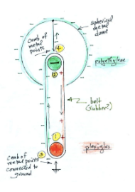
The charge of the head on the Van de Graaff generator depends on the materials of the inner combs (in this example, polyethylene and plexiglass) and belt (rubber) therefore it is possible your Van de Graaff generator might be positively charged instead of negatively charged. Additionally, if the combs were swapped, the charge of the head will be flipped.
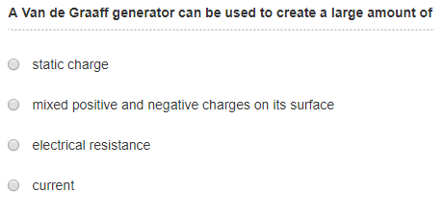
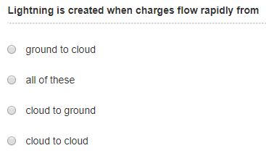

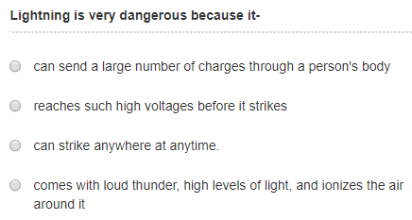
1) What happened to the pie tins and why?

2) What happened to the "tinsel" and why?

3) What happened to the fur and why?

4) What happened to the blond hair and why?

