Trigonometry

SOH CAH TOA
Disclaimer
- a statement that denies something, especially responsibility!
- I am NOT teaching you math—I am NOT teaching you Trig—I am teaching you how to push buttons on a calculator!

Basic Trig
- is really about 3 functions which your math teacher will actually teach you in Sec. IV or V.

Sine sin SOH
Cosine cos CAH
Tangent tan TOA

Sin, cos and tan are ratios of the sides of a right angle triangle.

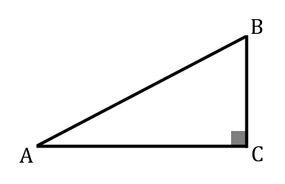

Pythagoras
Grade 10!

Angle Theta θ

Sin the ratio of the opposite side to the hypotenuse

Cos the ratio of the adjacent side to the hypotenuse

Tan the ratio of the opposite side to the adjacent side

