The Structure of DNA
Within the cell, we have seen that the organelles help make up the cytoplasm and out different jobs for the cell. The nucleus is surrounded by a membrane called the nuclear membrane.
The nucleus contains a molecule that controls all cell activity--deoxyribonucleic acid--DNA.
DNA is a large molecule and is coiled in order to fit inside the cell nucleus.

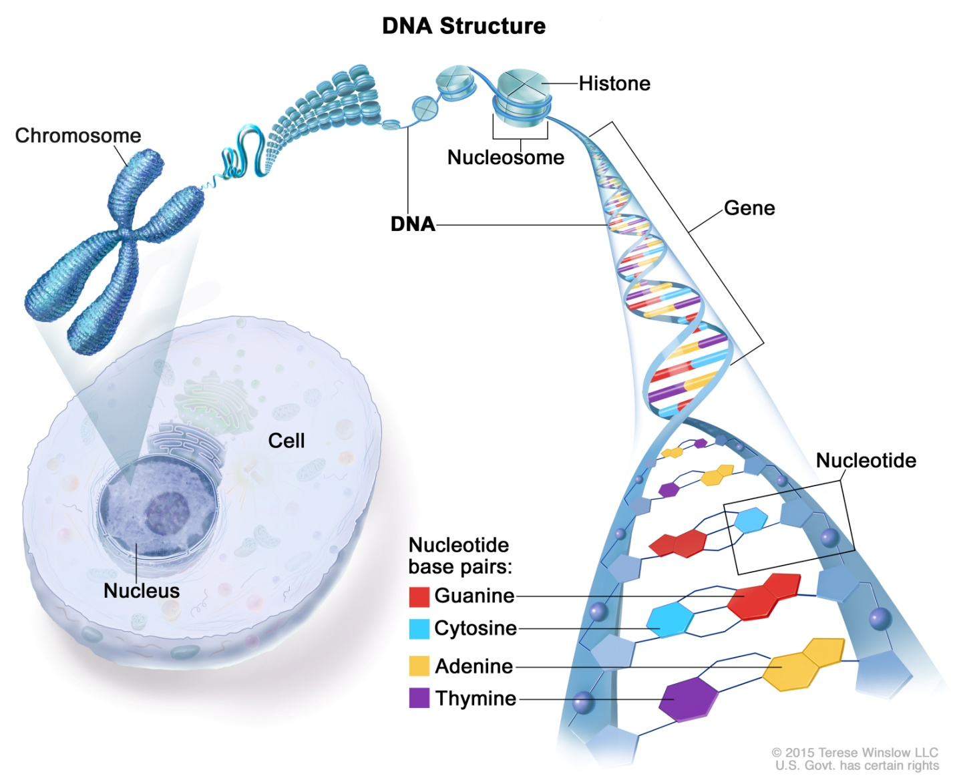

When unravelled we can see more clearly the shape of the DNA molecule.
DNA's shape is a double helix.
DNA is a molecule shaped like a double helix located inside the cell nucleus.
It consists of 2 sides like the sides of a ladder.
The sides are made up of sugar ____________________ and phosphate ____________.
The rungs of the ladder which connect the 2 sides are made of base pairs ____________.

- There are 4 bases in DNA: _______________________________
_______________________________
_______________________________
_______________________________

- The pairs bind together specifically:

The general structure of DNA:

Because of the specific way in which base pairs bind together, if you know one strand of DNA you can figure out the complementary DNA strand.

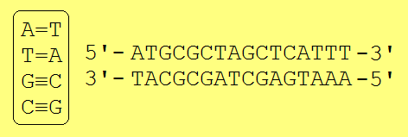

DNA contains a tremendous amount of information in the sequence of the base pairs.
No 2 people have the same DNA sequence (except for identical twins) and so your DNA makes you unique!
So your proteins are _________________________.
The sequence of base pairs or the order of ___________________________ are like instructions.
They work much the same way as letters are strung together to make words.
They direct the ribosomes in the cytoplasm to produce proteins which give you your characteristics and make you, YOU!!
DNA is the _____________________________ that instructs the ________________________
to make which _________________________________.

