The Inclined Plane

The function of the inclined plane is to reduce the effective weight of the object.
An object being pulled up an inclined plane requires less force than an object hoisted vertically.

Check your lab measurements:

Newton Spring Scale Reading Newton Spring Scale Reading
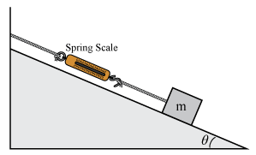

Weight (Fg) of cart = _______________ Force at 20 º = _______________

When an object is pulled up an inclined plane a significant portion of the total weight of the object is supported by the ramp and the rest supported by the person pulling.
How much of this weight is supported by the ramp and how much must be pulled by the person depends on the angle of inclination of the ramp.
This concept is illustrated in the diagram below in which W represents the total weight of the object, W_{y} represents the portion of the weight supported by the ramp and W_{x} represents the portion of the weight "felt" or actually pulled by the individual.
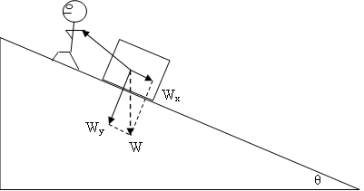
Components of an object's weight supported by an inclined plane and person.
https://www.teachengineering.org/lessons/view/duk_heaveho_music_less
The force pulling a sled along the ground at an angle can be separated into x and y or horizontal and vertical components:

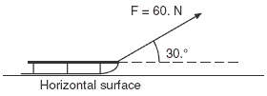

The Weight or force of gravity of an object on an inclined plane can also be resolved into x and y or horizontal and vertical components.

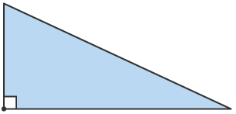

The force of gravity always acts straight down!!
Problems

1. What is the force necessary to pull a 790 kg roadster up a 75 º ramp?

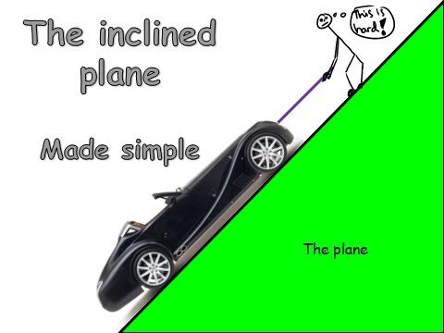

2. What is the magnitude of the force that would pull a block down a ramp at an angle of
30. º.

