September 2020 Covid Time (https://www.youtube.com/watch?v=otCpCn0l4Wo)
Class 1
The Cell
Cells are the basic building blocks of all living things, from amoeba, to ants, to elephants!

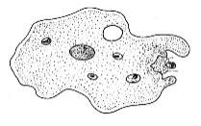
- The CELL is the basic unit of life.
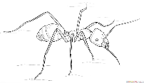
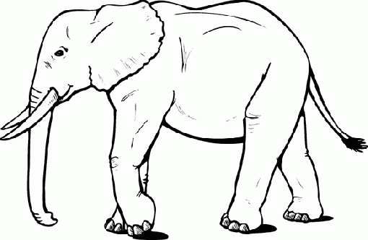

THE STRUCTURE AND FUNCTION OF THE HUMAN CELL:
The human body consists of 37 trillion cells--you cannot count this high in your lifetime!
Most cells can only be observed under a microscope—HW: Research cells you CAN see!
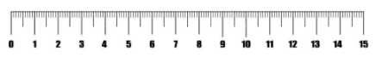

Get out your 15 cm (6 inch) ruler.
15 cm = 150 mm = 150 000 µm

The human eye can only see as small as 0.1 mm or 0.001 µm

Sizes (in micrometers) of various cells:
human egg ovum __________
human sperm __________
E. coli bacterium __________
SARS Cov-2 virus __________

Most microscopes only allow us to distinguish three components of the cell:
- the cell membrane
- the nucleus
- the cytoplasm.

Homework
- This afternoon or at the 2 min break put an egg in a glass and cover it with vinegar and keep it until next time--make observations (write them down quickly here)--then we’ll talk next class.
https://www.exploratorium.edu/snacks/naked-egg
- Safety is always IMPORTANT so wash your hands after handling the egg and do not touch your face!!!! Sound familiar??
https://extension.umn.edu/preserving-and-preparing/handling-eggs-prevent-salmonella#:~:text=Salmonella%20doesn't%20make%20the,eggs%20are%20contaminated%20with%20Salmonella

The CELL MEMBRANE is a flexible barrier that surrounds the cell content allowing the cell to interact with its environment.

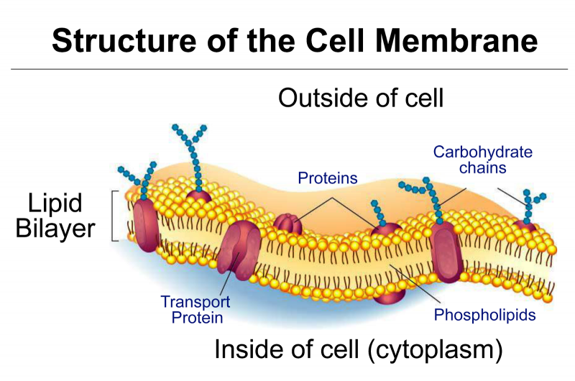 | 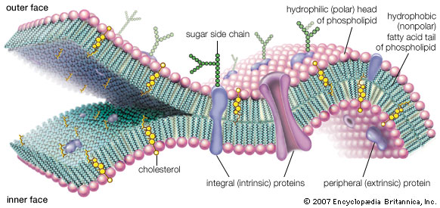

The CYTOPLASM is the gelatinous fluid inside the cell membrane and outside the nucleus.

The NUCLEUS can easily be distinguished by its darker color. It is the cell’s control center

An electron microscope provides a more detailed viewing of the cell.
The cytoplasm is made up of a clear gelatinous substance called the CYTOSOL.
The cytosol envelops small structures called ORGANELLES.
The organelles are:
- ________________________________
- ________________________________
- ________________________________
- ________________________________
- ________________________________
- ________________________________
- ________________________________
- ________________________________
- ________________________________
https://www.google.ca/url?sa=i&url=https%3A%2F%2Fwww.yourgenome.org%2Ffacts%2Fwhat-is-a-cell&psig=AOvVaw00RAGjWGAgFDBMrdHp6kL2&ust=1600018242836000&source=images&cd=vfe&ved=0CAIQjRxqFwoTCOidqdqS5OsCFQAAAAAdAAAAABAU

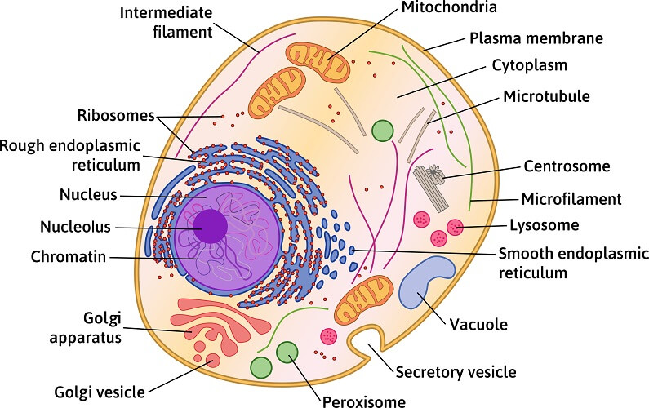
Cell Structures Worksheet 1

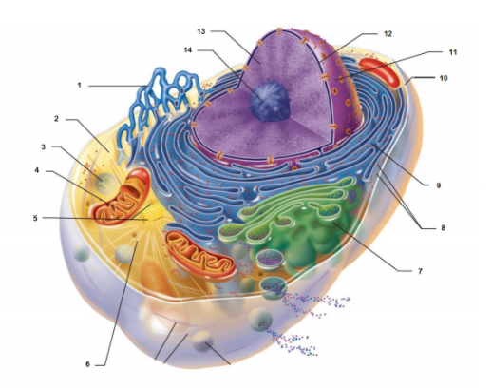

Structure | Number | Organelle | Number
cytosol |  | golgi apparatus
lysosome |  | nucleus
cell membrane |  | ribosomes
rough endoplasmic reticulum |  | smooth endoplasmic reticulum

Watch the following video until the 21:39 mark: https://www.youtube.com/watch?v=RKmaq7jPnYM
CELL STRUCTURES WORKSHEET 2
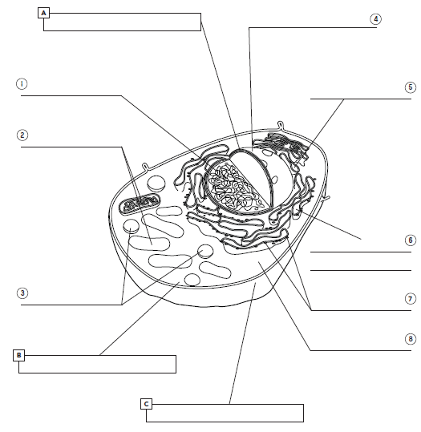

Label the numbered components.
i) Label the numbers.
ii) Indicate the functions of the lettered components.

