Solubility Equilibrium

Donate
Please watch The Science Guys Rock Candy video paying close attention to the science at the end of the video.
https://www.youtube.com/watch?v=VpOU0Fo7QfU
Solubility is the ability of a substance to dissolve.
The two participants in the dissolution process are the solute and the solvent.
The solute is the substance that is being dissolved, and the solvent is the substance that is doing the dissolving.
For example, sugar is a solute and water is a solvent.

Solution = solute + solvent
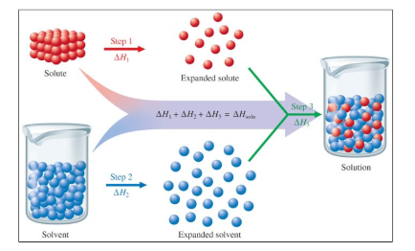
Notice that there are actually 3 processes involved and therefore 3 molar enthalpies...but that is for CEGEP.
We only calculated ∆Hsoln or the molar enthalpy of solution back in October.

There are many different types of solutions--not just a solid dissolving in water.

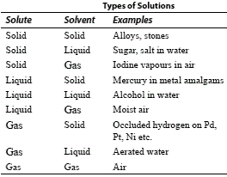

We are going to concentrate (no pun intended) on solutions made by dissolving an ionic compound into water.

Table salt or NaCl(s) dissolves in water to form salt water:
NaCl(s) ↔ Na⁺(aq) + Cl⁻(aq)

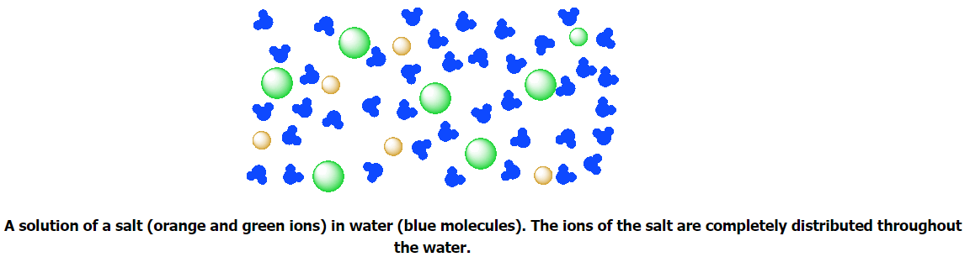
https://www.youtube.com/watch?v=xdedxfhcpWo

Remember electrolytic dissociation?
Not only does the salt dissolve in the water to make a solution, it also dissociates into ions because NaCl is an ionic compound.
Did you notice the equilibrium double arrows??

Dynamic Equilibrium
https://www.youtube.com/watch?v=JsoawKguU6A

If you dissolve only a small amount of salt in the water then ALL of the salt will dissolve and you will have an unsaturated solution.
But...if you try to dissolve a large amount of salt in the water then not all of it will dissolve and you will have a SATURATED solution and there will be residue sitting at the bottom.

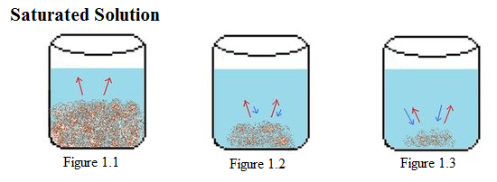
Initially you will not have a saturated solution.
There will only be a forward "reaction" -- the dissolving of solute into the solvent. (Figure 1.1)
But...then some of the dissolved solute will start to crystallize back out in the reverse "reaction" (Figure 1.2)
When the rate of the forward reaction of dissolving = the rate of the reverse reaction of crystallization is equal then a saturated solution exists. (Figure 1.3)
A saturated solution is a system at equilibrium.

Defn of Solubility
- the maximum amount of solute that can be dissolved in a solvent at equilibrium

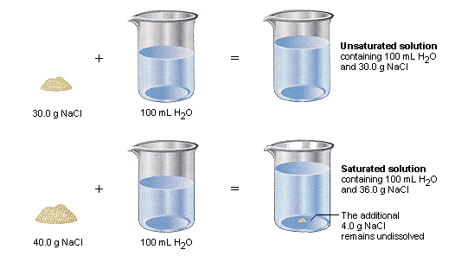
The beaker with the saturated solution is at equilibrium.
It does not look like it because the beaker is open but...all the action is IN the solution--the solid at the bottom is still dissolving and dissolved solute is crystallizing back out.
dissolving ↔ crystallization
There are no MACROSCOPIC changes.
But...at the MICROSCOPIC level dissolving and crystallization are taking place at the same rate.
If it makes you feel better draw a lid on the beaker and call it closed!

The Quantitative Aspect of Solubility I
Solubility Graphs
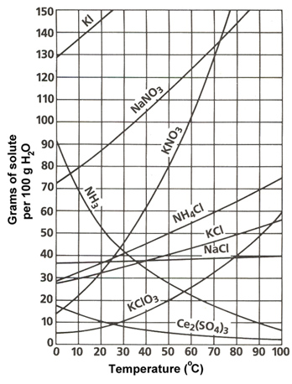
Please note that on solubility graphs:
i) Everywhere along a curve is a saturated solution.
ii) Below a curve is an unsaturated solution.
iii) Above the curve would be a supersaturated solution.

Quantitative Definition of Solubility
- is measured either in grams of solute per 100 g of solvent (g solute/100 g water) at a given temperature

- can also be measured in number of moles of solute per 1 L of the solution at a given temperature

The above graph indicates the solubility of different substances at different temperatures.

Solubility Table Problems
1) What is the solubility of Ce₂(SO₄)₃ at 40 ºC? ___________
2) How many grams of KClO₃ can dissolve in 50 mL of water at 80 ºC? ___________
3) If 75 g of KNO₃ are dissolved in 100 mL at 60 ºC, how many grams will crystallize out if the solution is cooled to 10 ºC?
___________
There are 3 types of solutions:
i) Unsaturated
- The solute concentration is lower than its equilibrium solubility.

- All of the solute dissolves in the solvent.

- More solute can be dissolved.
- There is no residue sitting at the bottom of the beaker.
ii) Saturated
- The solute concentration is equal to its equilibrium solubility at a given temperature.

- Only some of the solute dissolves in the solvent.

- No more solute can be dissolved.

- There is solute residue sitting at the bottom of the beaker.
iii) Supersaturated
- The solute concentration is higher than its equilibrium solubility at a given temperature.

- More solute has been dissolved than should be able to dissolve at the given temperature.

- There is no residue sitting at the bottom of the beaker.

- If another crystal of the solute is added to the solution all of the excess solute that had been dissolved will crystallize out.

- This is what you will do if you make rock candy.

How to make a supersaturated solution (or rock candy):
- Add a lot of sugar to a smaller amount of water at room temperature in a beaker.

- This results in a saturated solution with sugar residue sitting at the bottom.

- Heat the saturated solution until all of the sugar dissolves.

- You now have an unsaturated solution at a high temperature.

- Then cool the beaker back down to room temperature without disturbing it.

- If no solute drops back down out of solution to the bottom of the beaker you have a supersaturated solution.

- If you add more solute e.g. a sugar covered stick then the extra solute that dissolved into the water at the higher temperature will now come out of solution, sometimes dramatically.

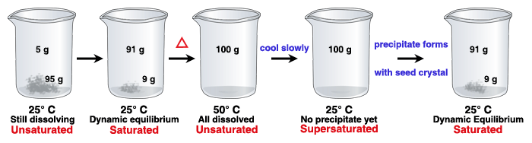

IB e assessment questions (or just a good inquiry questions):
What is the general trend of solubility of a solid in water? _____________________________
Any exceptions? __________________________________________________________
What is the state of NH₃ at standard temperature and pressure conditions? ___________
What generalization might you come to because of the trend for NH₃?

____________________________________________________________________________
Does the following graph justify your generalization? Explain.

____________________________________________________________________________

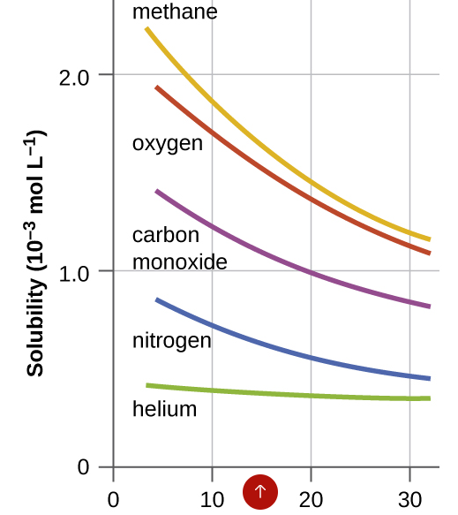

RECALL:
Equilibrium is the state at which the concentrations of products and reactant are constant after the reaction has taken place.
Reactants ↔ Products

Remember Keq?
Keq = [Products]
[Reactants]

Keq was a ratio of the concentration of the products to the concentration of the reactants at equilibrium raised to their coefficients from the BCE.

A Keq > 1 means at equilibrium what is present? _____________________________________

A Keq < 1 means at equilibrium what is present? _____________________________________

The concentrations must be measured in mol/L.

No solids or liquids are included!

Well, there is a special Keq when ionic solids dissolve--Ksp or Solubility Product Constant.
Ksp = [Products]
[Reactants]

NaCl(s) ↔ Na⁺(aq) + Cl⁻(aq)
Ksp = [Na⁺(aq)] [Cl⁻(aq)]
Why isn't NaCl(s) included?
The Ksp which is a constant or number is a large number for this particular salt. Why?
Well...the Ksp or Keq is a ratio of the products present to the reactants present AT EQUILIBRIUM which means in this case at equilibrium there are many many ions present.

Ksp for NaCl is approx. = 37 but this is a useless number to know because:

Ksp is used for “insoluble” compounds.

Ksp is not used with a soluble compound such as NaCl.
But you can do a calculation:
Molar mass NaCl = 58.5g/mol
Solubility NaCl at 20°C = 35.9g/100mL solution
Using dimensional analysis to convert g/mL into mol/L:

_________________________________________________________________________

Therefore the molarity of a saturated solution of NaC is 6.14 mol/L.
Ksp = [Na⁺(aq)] [Cl⁻(aq)]
Therefore Ksp = (6.14)² = 36.77
So...the Ksp for NaCl > 1 therefore? _____________________________________

The Quantitative Aspect of Solubility II
A substance is considered soluble if its solubility is greater than 0.1 mol/L at
This is not an arbitrary cut off.
It was chosen because most substances have solubilities either much greater or much less than this number.
Either a solution can be made by a lab tech that has a concentration of 0.1 mol/L or not.
Therefore a solute is either soluble or insoluble.

There used to be 3 ways to describe the solubility of a solution:
i) Soluble
ii) Slightly Soluble
iii) Insoluble
But...the second one is no longer used--but you will still see it on solubility charts.

Solubility products (Ksp) are Equilibrium Constants
Barium sulfate is almost insoluble in water.
It is not totally insoluble—very small amounts do dissolve--just not enough to make a 0.1 M soln.
This is true of any "insoluble" ionic compound.
If solid barium sulfate is shaken with water, a small amount of barium ions and sulfate ions break away from the surface of the solid and go into solution.
Over time, some of these return from solution to stick onto the solid again--a saturated soln forms.
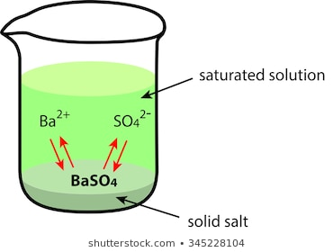

An equilibrium is established when the rate at which some ions are breaking away from the solid lattice is exactly matched by the rate at which others are returning.
Consider the balanced equation for the barium sulfate reaction:
BaSO4(s) ⇌ Ba²⁺(aq) + SO4⁻² (aq)
The position of this equilibrium lies very far to the left.
The great majority of the barium sulfate is present as solid—​there are no visible changes to the solid.
However, the equilibrium does exist, and an equilibrium constant can be written.
The equilibrium constant is called the solubility product, and is given the symbol K_{sp}.
Ksp = [Ba²⁺(aq)][SO4⁻² (aq)]
For simplicity, solubility product expressions are often written without the state symbols--Butt....NEVER without CHARGES--IONS always have charges!
Ksp = [Ba²⁺][SO4⁻²]
Equilibrium is the state at which the concentrations of products and reactant are constant after the reaction has taken place.

Ksp is important when describing the solubility of slightly ionic compounds.
Ksp values are given to insoluble solutes.

There are 2 calculations:
1) Use the solubility of an insoluble compound in mol/L (of a saturated solution) to determine the Ksp value.
2) Use the Ksp value to calculate the solubility of an insoluble compound.

The solubility product constant Ksp describes the equilibrium between a solid and its constituent ions in a solution.
The value of the constant identifies the degree to which the compound can dissociate in water.
For example, the higher the Ksp value, the more soluble the compound is.
Ksp is defined in terms of activity rather than concentration because it is a measure of a concentration that depends on certain conditions such as temperature, pressure, and composition--it is influenced by surroundings.
Ksp is used to describe the saturated solution of ionic compounds.

Sample Problem #1
Calculate the Ksp value for the following insoluble compound when dissolved in water to produce a saturated solution of barium carbonate.
BaCO₃ has a solubility of 7.14 x 10 ⁻⁵ mol/L. Why is this ionic compound considered insoluble?
This solubility is only for a given temperature. As with any Keq, if the temperature is changed the value of Keq changes because the ratio of product concentrations to reactant concentrations will change.
i) Always write down the BCE for the dissociation of the compound into its ions.
BaCO₃(s) ⇌ Ba²⁺⁽aq) + CO₃⁻²(aq)
ii) Always write down the equilibrium constant expression.
Ksp = [Ba²⁺][CO₃⁻²]
The mole ratios are 1 to 1 to 1.
If (but this doesn't happen--but if it did) 1 mole of BaCO₃ were to all dissolve then 1 mole of Ba²⁺ and 1 mol of CO₃²⁻ ions would form.
But the solubility tells us that only 7.14 x 10 ⁻⁵ mol/L can dissolve at a given temperature.
So if enough barium carbonate dissolves to make a 7.14 x 10 ⁻⁵ mol/L solution then there will be 7.14 x 10 ⁻⁵ mol/L barium ions and 7.14 x 10 ⁻⁵ mol/L carbonate ions in the saturated solution.

Ksp = [Ba²⁺][CO₃⁻²]
= 7.14 x 10 ⁻⁵ x 7.14 x 10 ⁻⁵
= 5.10 x 10 ⁻⁹
This value is much less than 1.
Therefore at equilibrium in the saturated solution there are very few ions and mostly solid residue sitting at the bottom of the beaker.
This problem could be made more difficult if the solubility were given in g/L or mg/mL etc.
The solubility must be in mol/L.
And it can be made more difficult because the mole ratio of the ions is not 1:1 so...

Sample Problem #2
The aqueous solubility for compound lead (II) iodide PbI₂ is 0.54 grams/100 ml at 25 °C.
Determine the Ksp for PbI₂.

PbI₂(s) ⇌ Pb²⁺(aq) + 2 I⁻(aq)

Ksp = [Pb²⁺] [I⁻]²

Please note that Keq are ratios of Product Concentrations raised to its Coefficient from the BCE to the Reactant Concentrations raised to its Coefficient from the BCE.
Use dimensional analysis to change the solubility of 0.54 g/100 mL into mol/L.

____________________________________________________________________________

0.54 g/100 mL of PbI₂ = 0.01171 mol/L PbI₂

But 1 mole of PbI₂ would split up into 1 mol of Pb²⁺ ions and 2 mol of I⁻ ions.

So...0.01171 mol/L PbI₂ (dissolved) would result in 0.01171 mol/L Pb²⁺ and
0.02342 mol/L I⁻ ions--do the stoichiometry!

Ksp = [Pb²⁺] [I⁻]²
= (0.01171) x (0.02342)²
= 6.422 x 10 ⁻⁶

BTW--which salt is more soluble and how do you know?

____________________________________________________________________________

____________________________________________________________________________

____________________________________________________________________________

How are Ksp and Solubility Related?
The relation between solubility and the solubility product constants is that one can be used to derive the other. In other words, there is a relationship between the solute's molarity and the solubility of the ions because KsqKsq is the product of the solubility of each ion in moles per liter.

Sample Problem #3
If you can use solubility to find the Ksp value then you can do the converse and use the Ksp value to determine the solubility of an insoluble compound.

The Ksp of AgI at 25 ºC is 8.5 x 10 ⁻¹⁷.
What is the molar solubility of AgI at that temperature?
What do you do every time?

Write the BCE: __________________________________________________________
Leave space under!

Write the Ksp expression: ____________________________________________________

AgI(s) ↔ Ag⁺(aq) + I⁻(aq)
Solubility? Concentration? Concentration?
x x x

Let x = the solubility of AgI

The mole ratios are 1:1:1.

So if x is the solubility in mol/L of AgI then x = the concentration of the silver ions and the concentration of the iodide ions.

Ksp = [Ag⁺] [I⁻]
8.5 x 10 ⁻¹⁷ = (x) (x)
8.5 x 10 ⁻¹⁷ = x²
√8.5 x 10 ⁻¹⁷ = √x²
9.2 x 10 ⁻⁹ = x

But we let x = the solubility of the AgI in mol/L therefore:
ANS = 9.2 x 10 ⁻⁹ mol/L is the solubility of AgI.

Now how could we make it harder?
Ask for the solubility in g/L or mg/mL etc.
Use a compound that does not have a 1:1:1 ratio of moles of compound to moles of ions.

Sample Problem #4
The Ksp for Be(OH)₂ is 6.92 x 10 ⁻²².
What is the solubility of beryllium hydroxide in mol/L?

Be(OH)₂(s) ↔ Be²⁺(aq) + 2 OH⁻(aq)
Solubility x x 2 x
Every 1 Be(OH)₂ breaks up into 1 Be²⁺ ion and 2 OH⁻ ions.

Ksp = [Be²⁺] [OH⁻]²
6.92 x 10 ⁻²² = (x) (2x)²

Oh Oh!! Yes the concentration of the hydroxide ion has to be doubled AND in the Ksp has to be raised to its coefficient.
You are going to forget to do this!!
So...
6.92 x 10 ⁻²² = 4 x³
Now solve for x:

