Name: ______________________________ Partner: _____________________________
Significant Digits Lab
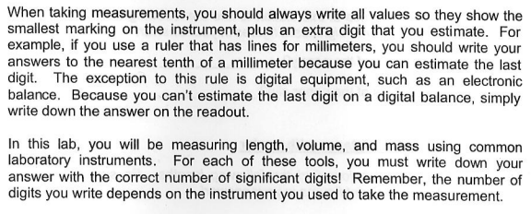

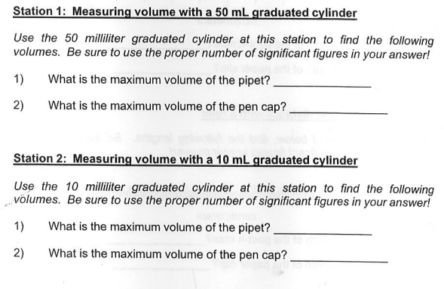

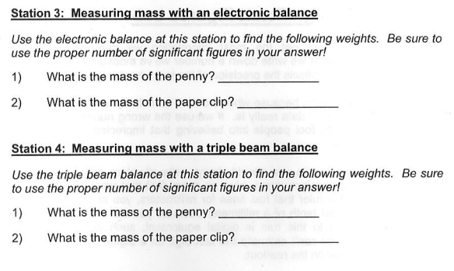
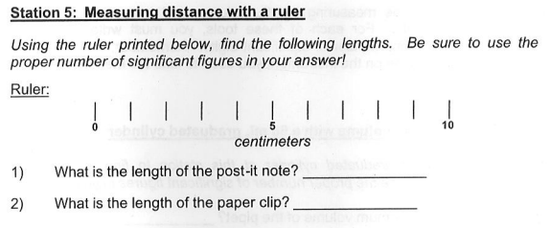

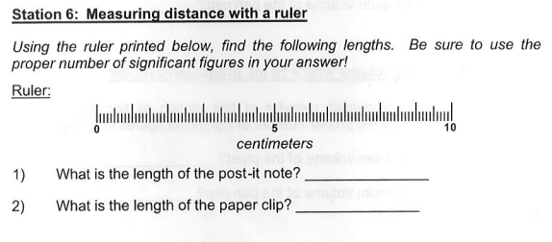
What is the difference between the 2 rulers? __________________________________
___________________________________________________________________________

Station 7: Measuring thickness with calipers

1) Using the calipers, measure the inside diameter of the test tube. ___________
2) Using the ruler, measure the inside diameter of the test tube. ___________

Station 8: Measuring temperature of water with a thermometer

1) Temperature of water with thermometer 1. ___________
2) Temperature of water with thermometer 2. ___________

What is the difference between the 2 thermometers? _____________________________
____________________________________________________________________________

