Series Circuits Worksheets

1. In this circuit, three resistors receive the same amount of current (4 amps) from a single source.
Calculate the amount of voltage “dropped” by each resistor.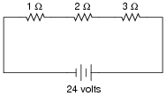

2. Re-draw this circuit in the form of a schematic diagram:
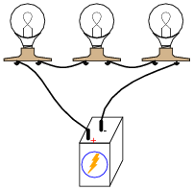
3. Suppose I connect two resistors in series with one another, like this:
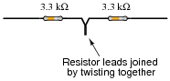
How much electrical resistance would you expect an ohmmeter to indicate if it were connected across the combination of these two series-connected resistors?
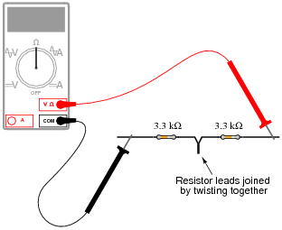
4. What would happen if three 6-volt light bulbs were connected as shown to a 6-volt battery? How would their brightness compare to just having a single 6-volt light bulb connected to a 6-volt battery?
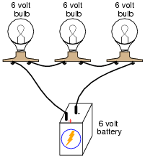
5. Light-emitting diodes, or LEDs, are rugged and highly efficient sources of light. They are far more rugged and efficient than incandescent lamps, and they also have the ability to switch on and off much faster because there is no filament inside needing to heat or cool:
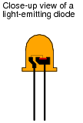
LEDs are low voltage devices, typically rated in the range of 1.5 to 2 volts DC maximum. Single diodes generally draw low currents as well, about 20 milliamps each. The problem is, how do you operate an LED from a typical electronic power source, which may output 24 volts DC or more?
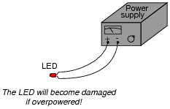
6. Calculate the necessary series “dropping” resistor value to operate a 1.8 volt, 20 mA LED from a 34 volt DC power source.

7. Complete the table of values for this circuit:
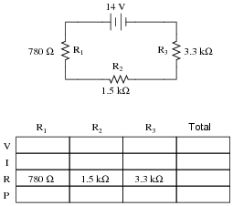

8. Complete the table of values for this circuit:
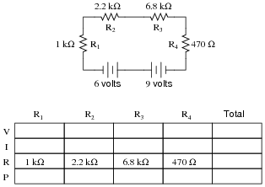

Parallel Circuits

1. In this circuit, three resistors receive the same amount of voltage (24 volts) from a single source. Calculate the amount of current “drawn” by each resistor. 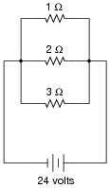

2. What will happen to the brightness of the light bulb if the switch in this circuit is suddenly closed?
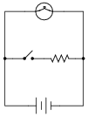
3. Determine the amount of voltage impressed across each resistor in this circuit:
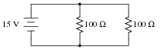

4. According to Ohm’s Law, how much current goes through each of the two resistors in this circuit?
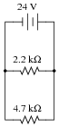
Draw the paths of all currents in this circuit.

5. Qualitatively compare the voltage and current for each of the three light bulbs in this circuit (assume the three light bulbs are absolutely identical):
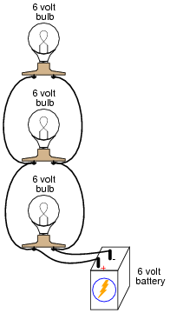
6. Calculate the total amount of current that the battery must supply to this parallel circuit:
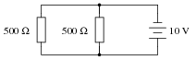
Calculate total resistance.
7. In a series circuit, resistance increases and conductance decreases with the addition of more resistors:
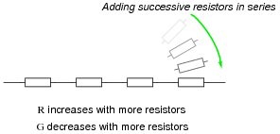
Describe what happens to total resistance and total conductance with the addition of parallel resistors:
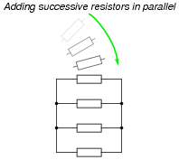

8. Suppose I connect two resistors in parallel with one another, like this:
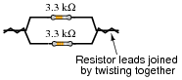
How much electrical resistance would you expect an ohmmeter to indicate if it were connected across the combination of these two parallel-connected resistors?
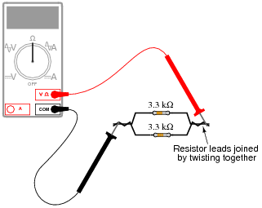

9. Complete the table of values for this circuit:
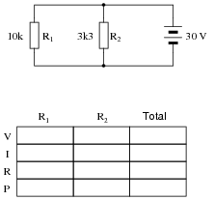
10. Complete the table of values for this circuit:
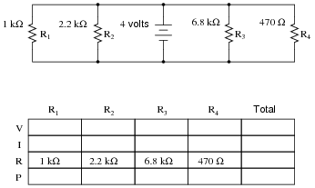

11. What will happen in this circuit as the switches are sequentially turned on, starting with switch number 1 and ending with switch number 3?
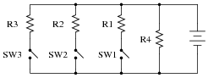
Describe how the successive closure of these three switches will impact:
• The voltage drop across each resistor
• The current through each resistor
• The total amount of current drawn from the battery
• The total amount of circuit resistance “seen” by the battery

