Screw Gear Systems
- contain a SCREW and a NUT
- the threads of the screw and the nut must match
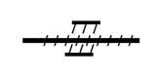
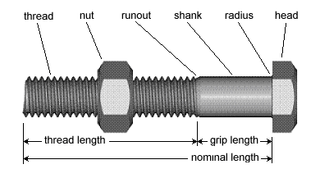
Screw Gear System Type 1
- the screw is the driver
- transforms rotational motion into translational motion
- has the nut connected to the screw so the nut cannot rotate
- e.g. jack to lift a car
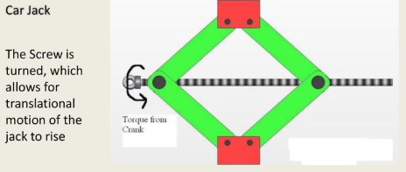
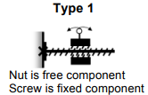
Screw Gear System Type 2
- the nut is the driver
- transforms rotational motion into rotational motion
- has the nut fixed so that its possible motion is rotational
- e.g. wrench
