Scientific Notation Practice Problems

# Significant Figures Scientific Notation
- 230.005 m ________________ ______________

- 109,000 kg ________________ ______________

- 328.46 mm ________________ ______________

- 0.00607 cm ________________ _____________

- 5.017 L ________________ ______________

- 8000 km ________________ ______________

- 0.057 g ________________ ______________

- 610.0 kPa ________________ ______________

# Significant Figures Non-Scientific Notation
- 6.54 x 10⁻⁵ m _________________ ______________

- 3.22 x 10⁴ g _________________ ______________

- 8.9256 x 10⁶ s _________________ ______________

- 2.11 x 10⁻² g _________________ ______________

- 9.52 x 10⁻⁹ m _________________ ______________

Directions: For #14-#16, use the ruler below to obtain your answer.

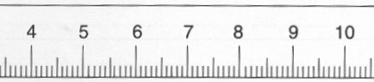

- This ruler measures to the nearest ___________ place.

- This means that we can estimate to the __________ place.

- The triangle above is pointing to a measurement of __________ (assume cm).

- 6.44 cm + 9.9009 cm 18. 4.44 m x 9.1 m

19. 55.43 g - 0.5 g 20. 67.8 L ÷ 103.7 L

