**Name: __________________________________________**

**Regular General Science**

**Secondary IV**

**Exam Review Package**

**December 20th 2017**

**10:55 a.m.—2:25 p.m.**

**Topics**

* **Ecotoxicology**
* **Forces**
* **Energy**
* **Electricity**

**Bring to the Exam:**

* **Multiple pencils**
* **Eraser**
* **Calculator or 2**
* **Ruler**
* **Kleenex**
* **Cough drops**
* **Water bottle**

**ST Regular General Review December 2017**

**1)**

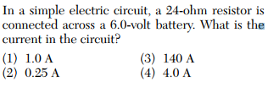

**2)**

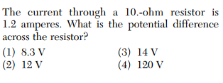

**3)**

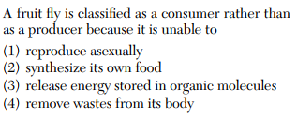

**4)**

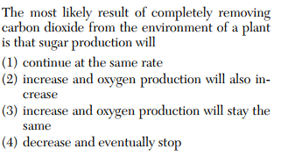

**5)**

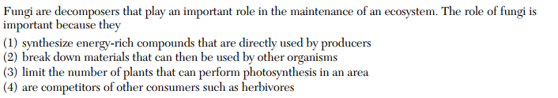

**6)**

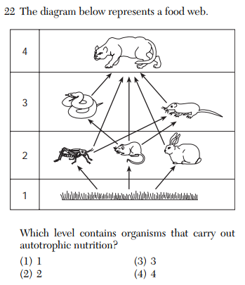

**7)**

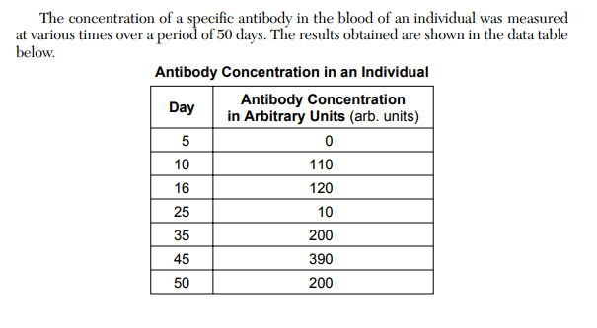

What is the independent variable? __________________________________________

What is the dependent variable? __________________________________________

Graph the data:

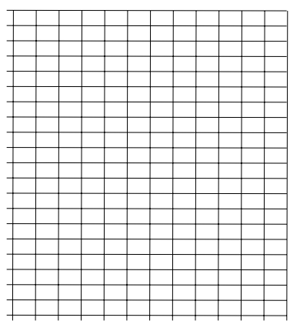

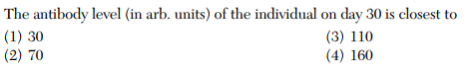

**8)**

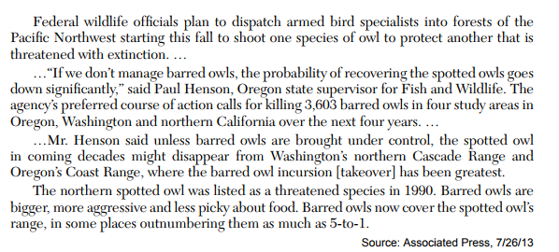

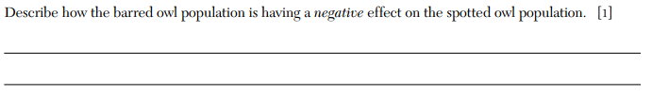

**9)**

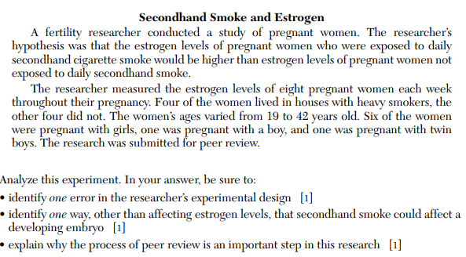

**10)**

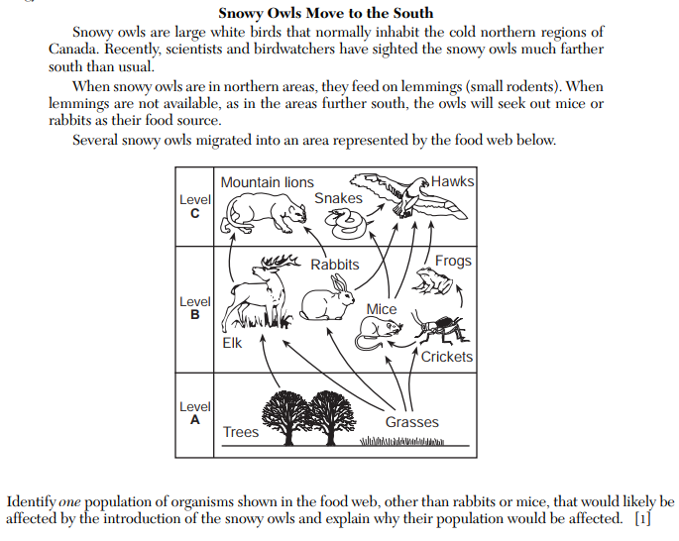

**11)**

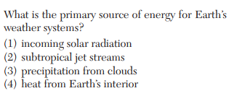

**12)**

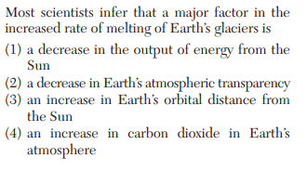

**13)**

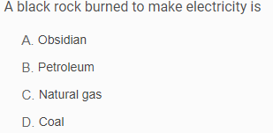

**14)**

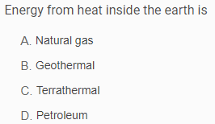

**15)**

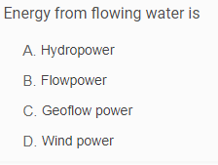

**16)**

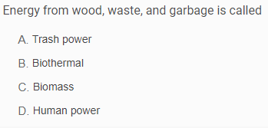

**17)**

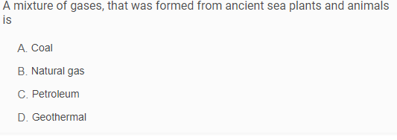

**18)**

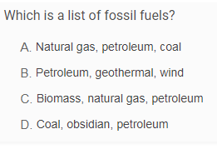

**19)**

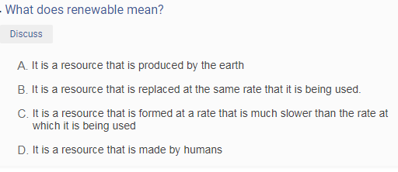

**20)**

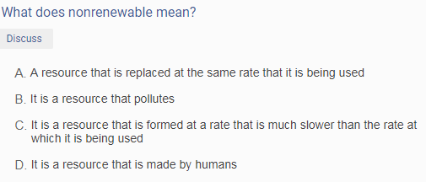

**21)**

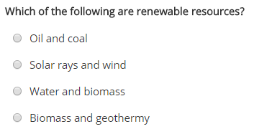

**22)**

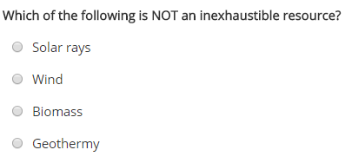

**23)**

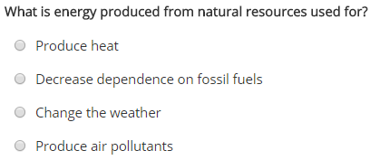

**24)**

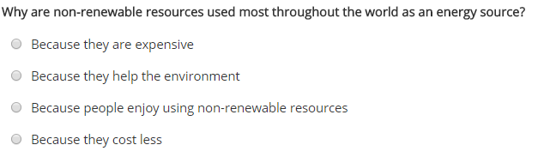

**25)**

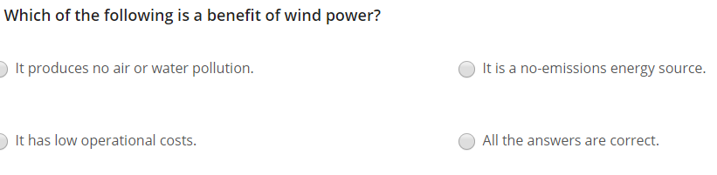

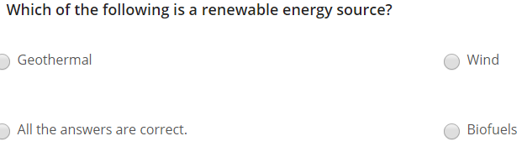**26)**

**27)**

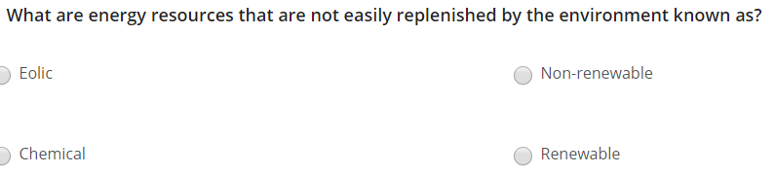

**28)**

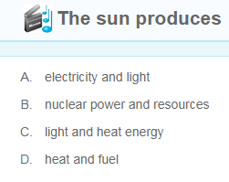

**29)**

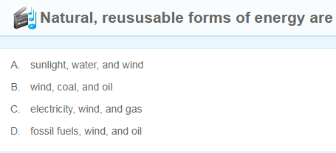

**30)**

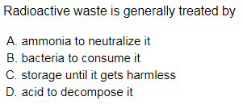

**31)**

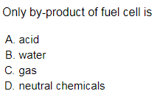

**32)**

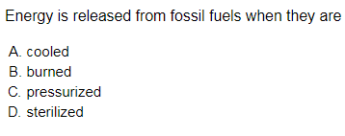

**33)**

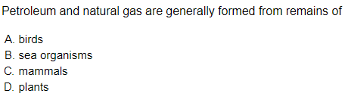

**34)**

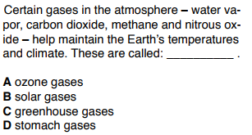

**35)**

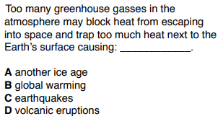

**36)**

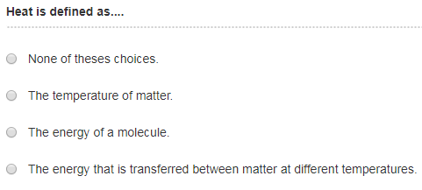

**37)**

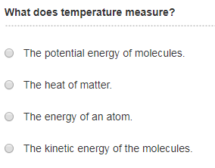

**38)**

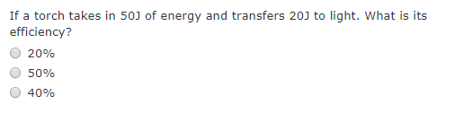

**39)**

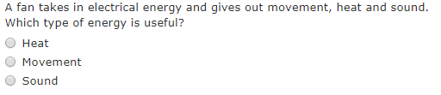

**40)**

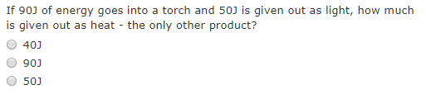

**41)**

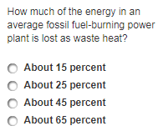

**42)**

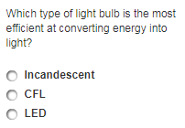

**43)**

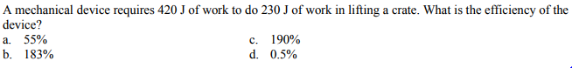

**44)**

What does Ohm’s Law state?

What is wrong with this graph even though the independent and dependent are correct?

Explain.

Can you calculate resistance ® from this graph? Explain. What would you have to do?

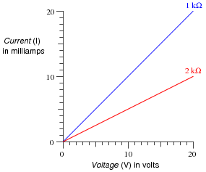

What units do you have to use when doing electricity problems?

**45)** Graph of Voltage vs Current for an Unknown Resistor

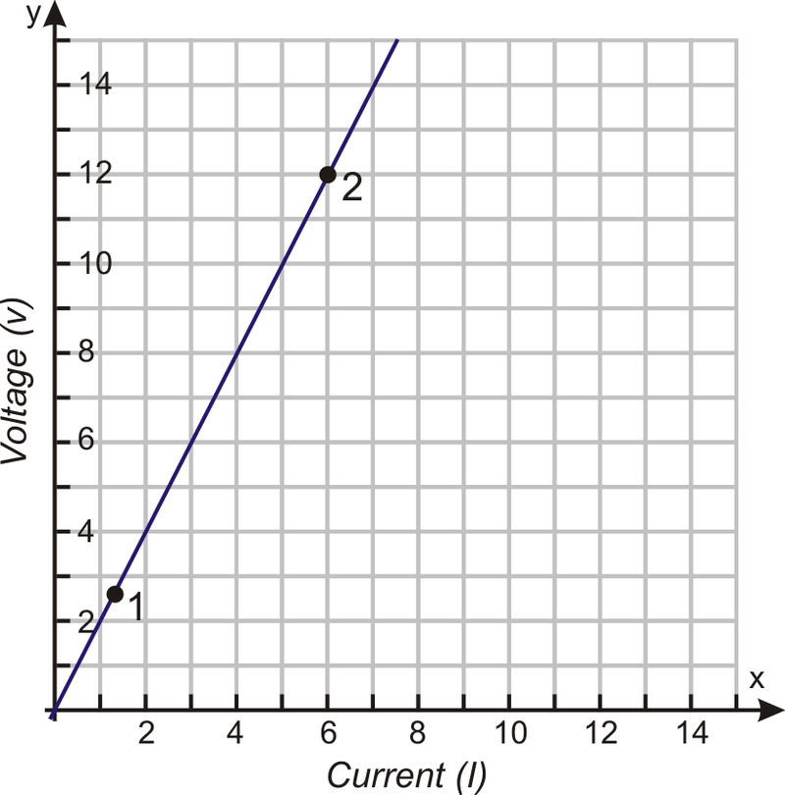

Calculate the resistance of the unknown resistor:

**46)** Indicate the Energy Transformations that take place from start to finish:



**47)**

What would be the gear ratio for the following set of gears?



