Name: __________________________________________

Advanced General Science
Secondary IV

Exam Review Package
December 20th 2017
10:55 a.m.—2:25 p.m.

Topics
- Ecotoxicology
- Forces
- Energy
- Electricity

Bring to the Exam:
- Multiple pencils
- Eraser
- Calculator or 2
- Ruler
- Kleenex
- Cough drops
- Water bottle

Review Advanced General Science December 2017

1)
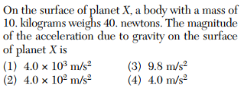
2)
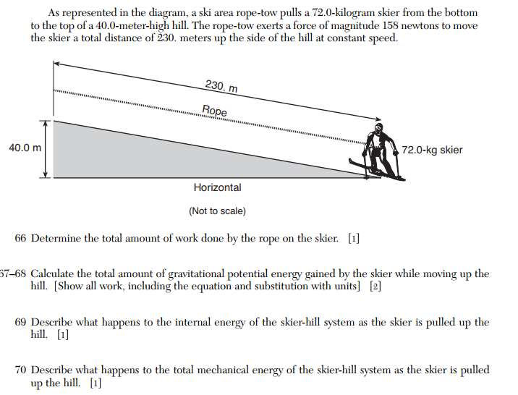
3)
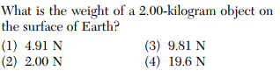

4)
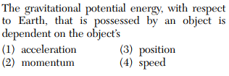
5)
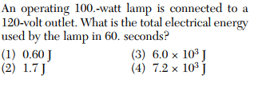
6)
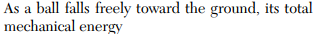
1) increases
2) decreases
3) stays the same
4) inverts
7)
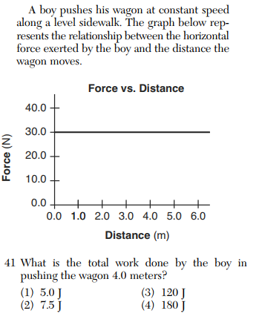
8)
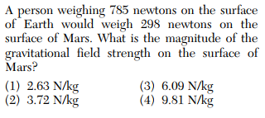
9)
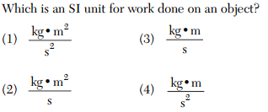
10)
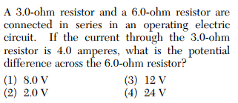
11)
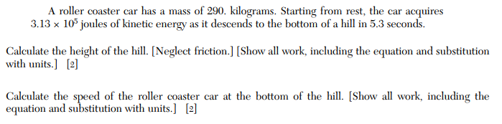

12)

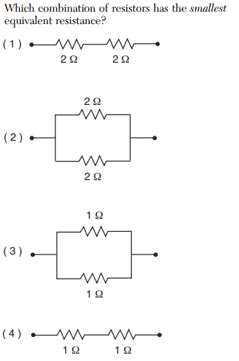

13)
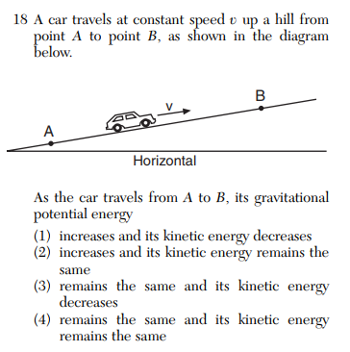

14)
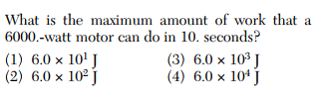
15)
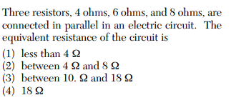
16)
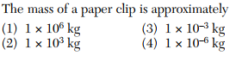

17)
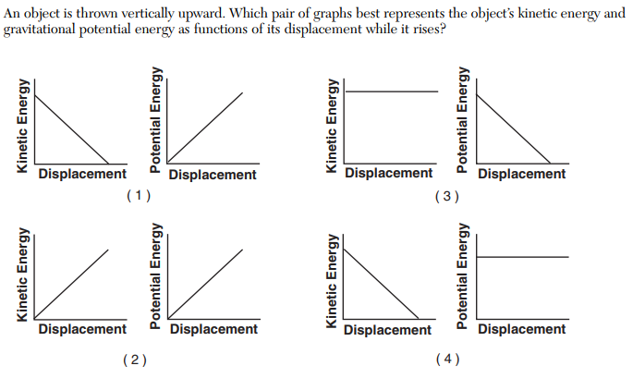

18)
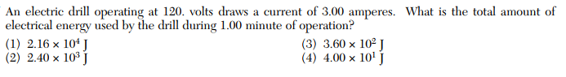
19)
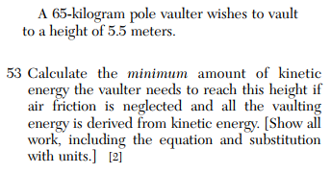
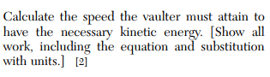
20)
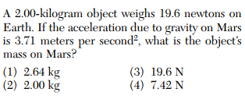
21)
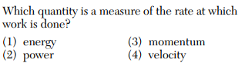

22)
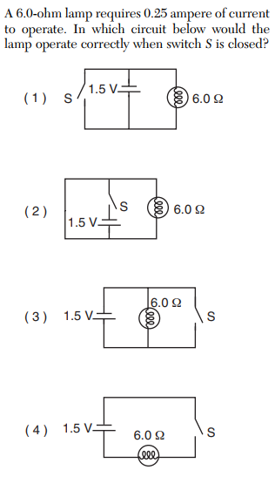

23)
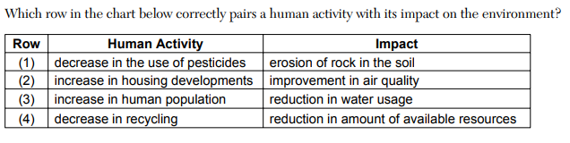

24)
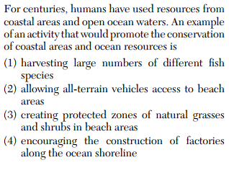
25)
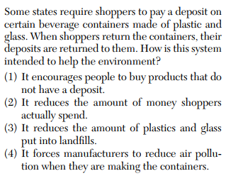

26)
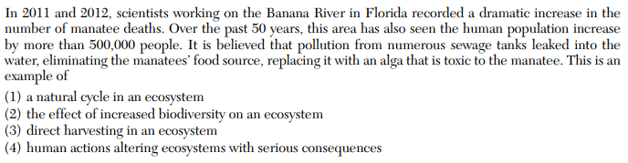
27)
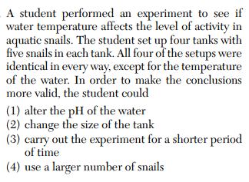
28)
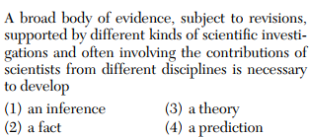
29)
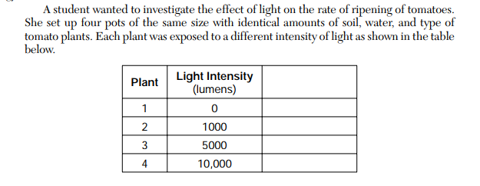
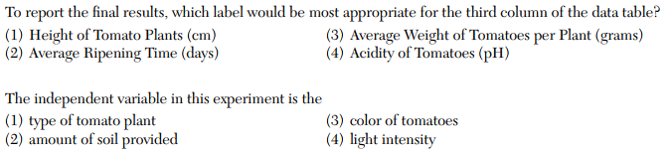
30)
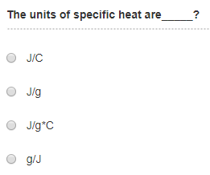
31)
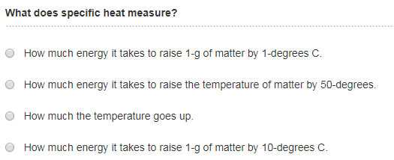
32)
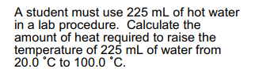
33)
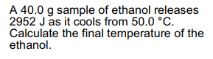

34)
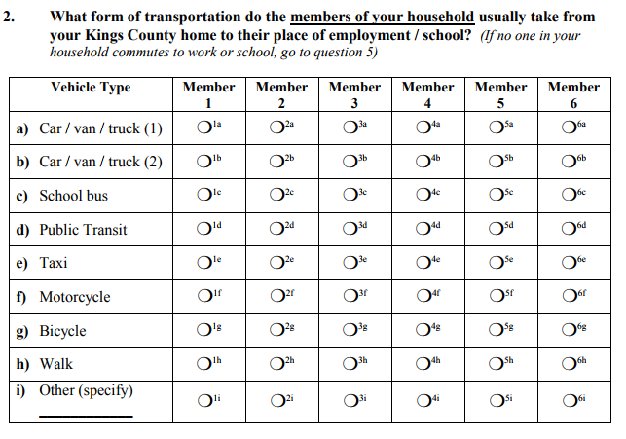
What is the above table a part of? Explain.

35)
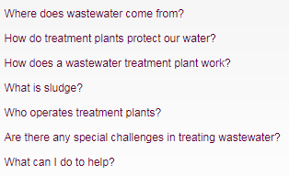

36)
Definitions of
i) Contaminant
ii) Bioaccumulation
iii) Bioconcentration
iv) Toxicity Threshold

37) What is the horizontal force responsible for pulling the block down the incline?
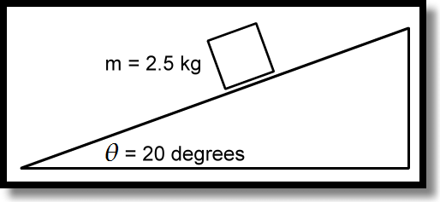
38)
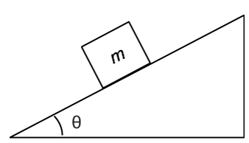

A 20.0 g object is placed on an inclined plane at a 40.0 º angle. What force would be necessary to push the object up the incline at a constant velocity?
39)
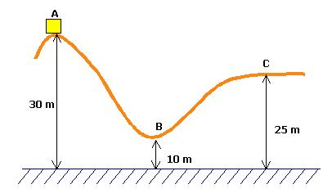
What would be the speed of the 1200 g cart at C if it started at rest from A?

