Name: ____________________ Date: _____________________
Harnessing Energy from Our planet
The Spheres of Our Planet:
The hydrosphere
The Lithosphere
The atmosphere
The biosphere

Renewable vs. Non-Renewable Energy:
Renewable Energy | - Energy from a source that is not depleted when used (does not get used up).
Non-Renewable Energy | - Energy from a source that is not easily replaced in nature.  - Once the source gets used up, you will need to generate more in order to obtain energy from this source.  - It may take thousands of years for these sources to replenish themselves.

Energy from the hydrosphere:
Hydraulic energy: ________________________________________________________
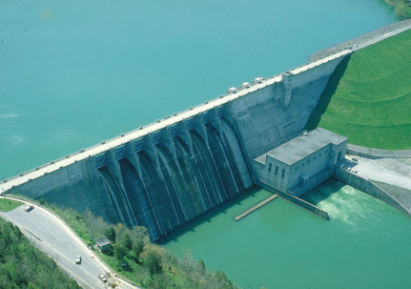
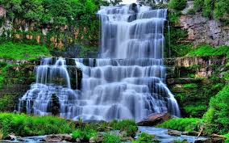

How do we obtain hydraulic energy?
- Hydroelectric power plants use the movement of falling water to _____________________ which are located inside __________________________.
- Water falling through a dam spins a turbine that _____________________________________________________________
- Hydroelectricity is the main source of energy in Quebec.
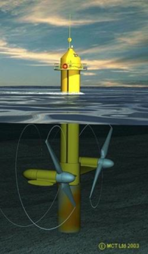
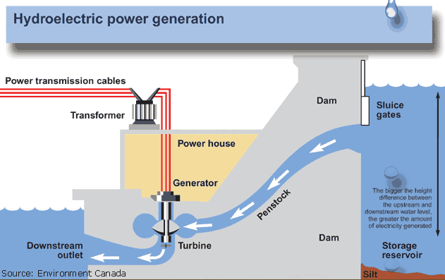
Wave Energy:
- Energy from the movements of currents.

How to obtain it?
  - Wave energy is produced when the energy contained in the movement of water is harnessed using buoys, which _______________________________.
  - Ocean currents are able to _____________________________, which are similar to wind turbines.
  - The mechanical energy produced by the movement of the buoys and blades can be ______________________________ energy.
Tidal Energy:
- Electricity can be generated from tides when water from a high tide is collected (sometimes using a dam) and then falls through turbines converting mechanical energy into electrical energy are used.
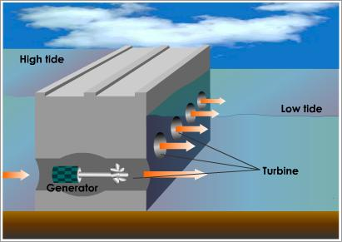

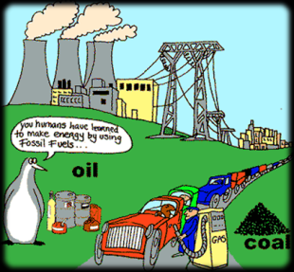
Energy from the Lithosphere:
Fossil Fuels:
- Fuels resulting from the ___________________________________________.
- These energy sources consist _____________________________.
- They form from the pressure of several layers of sediment over decaying organic matter.
- This process takes millions of years.
How do we obtain it?
- The burning of fossil fuels releases a lot of _______________________________.
- This thermal energy is used to create ____________ by boiling water.
- The steam creates __________________________________ connected to a generator.
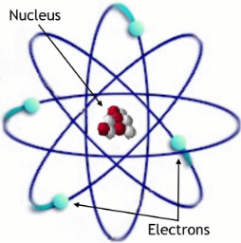
Uranium:
- It is a ___________________________ that occurs naturally in the Earth’s crust.
- Splitting the nucleus of these atoms produces a lot of nuclear energy.
- What is nuclear energy? _______________________________________________
- While nuclear energy does not release greenhouse gases such as in the burning of fossil fuels it has other consequences.
- What are the 2 main concerns surrounding the use of nuclear energy?
_________________________
_________________________
How do we obtain it?
- By bombarding nuclei with particles or other nuclei moving at high speeds you can cause the decay/transformation of radioactive nuclei. (break them down)
- This creates a large amount of ____________________, which is used ___________________ by boiling water.
- The __________________________ which allows a generator to create electricity.

Geothermics:
- Geothermal energy is the energy _________________________________________________.
- Found mostly where hot rock is located near the Earth’s surface (near volcanoes for ex.)
- This is a renewable source of energy that can be used for heating houses.
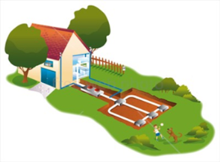

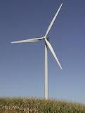
Energy from the Atmosphere:
- Wind Energy: The Energy that can be drawn from the wind.
Advantages:

Disadvantages:

How do we obtain it?
__________________________________________________________________________________________________________________________________________________________________________
Solar Energy:
- Solar energy is the energy that comes from the Sun in the form of radiation through the atmosphere.
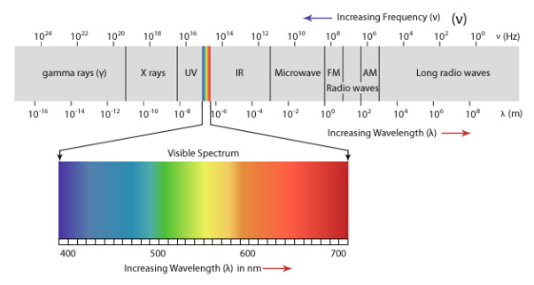
- Composition: 75% hydrogen and 25% helium

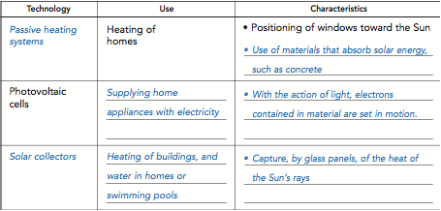

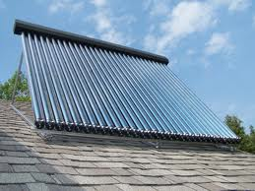
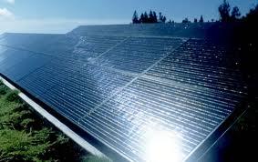
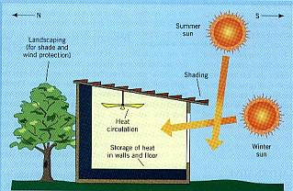

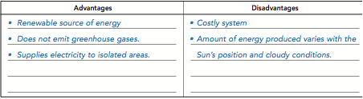

So which is which?
Renewable | Non-renewable

