How to Read Colour Codes on Resistors

Resistors are rather small and come in many different values of resistance.
If the manufacturer were to print the value of the resistor on the side of the resistor, it would be too small to read.
Thus a clever way was devised to tell the value of a resistor.
The resistors are all color coded.
All the resistors we use have 3 or 4 color bands on them.
Every color is different number.

The first colour band indicates the first number of the resistor value.

The second colour band indicates the second number of the resistor value.

The third colour band indicates the number of zeroes that follow the first
two numbers--the multiplier band.

If there is a fourth colour band it indicates the TOLERANCE—the acceptable percentage you are allowed to be “off” of the accepted resistance.

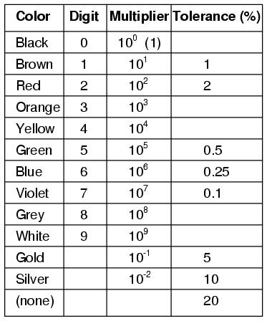

Example:

A resistor has the following banding pattern—Red—Green—Red—Silver.

What is the value of the resistor and its acceptable range?

