Reaction Mechanisms
The reaction mechanism describes the sequence of elementary reactions (steps) that must occur to go from reactants to products.
Reaction intermediates (intermediate products—IP) are formed in one step and then consumed in a later step of the reaction mechanism.

A catalyst will appear firstly as a reactant and “reappear” as a product.

The slowest step in the mechanism is called the rate determining step (RDS) or rate-limiting step.
RDS will have the highest activation energy i.e. highest bump (Khan Academy and McRae)

The molecularity of an elementary step describes the number of reactive partners in the elementary step.
e.g. 4 BF₃ + 3 H₂O → 3 HBF₄ + "B(OH)₃"

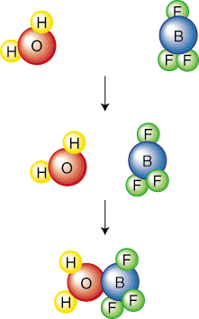
For example, the above elementary step is called bimolecular because two molecules collide.
Commonly, elementary steps are mono-, bi-, or termolecular.
The probability of four molecules colliding at exactly the same place and time is so small that we can safely assume that no reaction will ever be tetramolecular.
(http://www.sparknotes.com/chemistry/kinetics/mechanisms/section1.html)
Reactant bonds break (endo) and Product bonds form (exo).

As the bonds break and form the species go through a state called the activated complex.
The activated complex (AC) is a very high energy unstable species that appears at the top of every step/bump on an enthalpy graph.
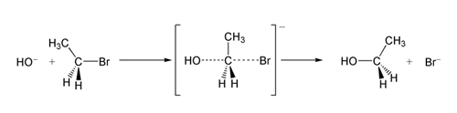

Intermediate products (IP) appear in the valleys or troughs of an enthalpy graph.

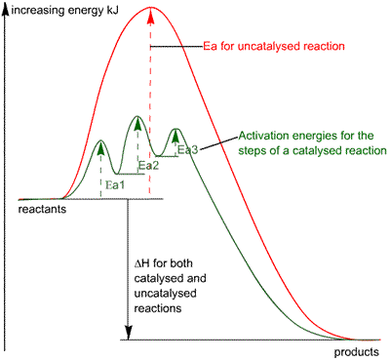

Reactions normally occur in a number of steps—especially if a catalyst is involved.
Some steps are slower than others. The slowest step is the RDS.
The more activation energy required the slower the step.
Slow steps have major impact on the overall reaction rate.
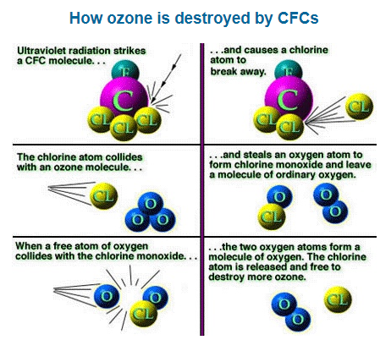
To better understand mechanisms, let us consider the following mechanism for the uncatalyzed decomposition of ozone, O₃:

UV energy + O₃ O₂ + O Slow

O + O₃ 2 O₂ Fast
_________________________________________________________

BCE: ______________________________________________________________________________
What would the enthalpy graph look like?

For the following reaction mechanism determine:
i) the BCE for the reaction
ii) the intermediate product(s)
iii) the catalyst (if there is one)
iv) the shape of the graph
v) the increase in the concentration of which species would cause the greatest increase in the speed of the reaction

A + B → C + D Fast
C + E → F + G Slow
F + H → I + B Fast
______________________________________________

i) ______________________________________________________________________

ii) _____________________________

iii) _____________________________

iv)

v) _____________________________ because _________________________________
______________________________________________________________________

