Rates of Reaction—Kinetics Notes 1

How fast a rxn takes place is the speed of the rxn or the rate of rxn.

If you are making a product to make money and/or to cure a disease, it is important to know how long the reaction takes to complete, before the product is produced.

****There is always going to be _________________ in the denominator!!!!

Always!!! *****

Usually:

Rate = ∆ [R] or Rate = ∆[P]
t t

Where [ ] is the concentration in mol/L

e.g. [HCl] = 0.1 mol/L or 0.1 M

You can measure the rate of the _________________________________ of a Reactant.

You can measure the rate of ____________________________________ of a Product.

the rate of rxn = _________________________________________

time

It does not have to only be the change in the concentration of a R or a P.

It can also be a change in:

- ___________________________________

- ___________________________________

- ___________________________________

- ___________________________________

- ___________________________________

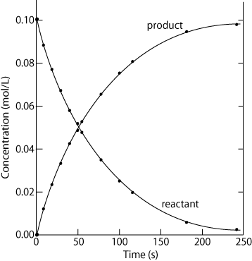
How to Calculate Rates of Reaction
Watch for:
1) which species the rate is wanted for
2) which species the information was given for
3) the units the rate is wanted in
4) which type of rate is wanted
- for a time interval
- for a specific point in time—instantaneous rate
- for the entire period of the reaction—the average rate

Problem
Consider the thermal decomposition of NO₂ gas at elevated temperatures, which occurs according to the following reaction:
2 NO₂(g) → 2 NO(g) + O₂(g)

Time (s) | [NO₂]
0 | 1.00 × 10⁻²
60 | 6.83 × 10⁻³
120 | 5.18 × 10⁻³
180 | 4.18 × 10⁻³
240 | 3.50 × 10⁻³
300 | 3.01 × 10⁻³
360 | 2.64 × 10⁻³

i) What is the rate of reaction from 120 to 300 s as the reactant NO₂ disappears?

ii) What is the rate of reaction from 180 to 360 s for the production of oxygen?

iii) What is the rate of production of nitrogen monoxide in g/Lmin from 180 to 360 s?

iv) What is the rate at 330 s?

iv) What is the average rate of disappearance of NO₂?

Average Rate = Total Change
Total Time

Zn metal reacting with HCl(aq)

http://www.s-cool.co.uk/gcse/chemistry/rates-of-reaction/revise-it/the-rate-of-a-chemical-reaction
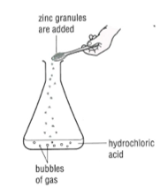

BCE:

____________________________________________________________

How could you measure the rate of the above rxn?

1. _______________________________________________________

2. _______________________________________________________

3. _______________________________________________________

4. _______________________________________________________

What would it be easiest to measure? and how?

First Rates Experiment
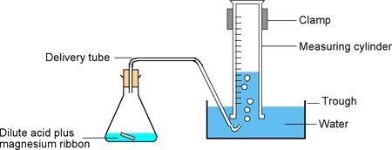

BCE

____________________________________________________________

NIE

____________________________________________________________

Which species were coming into contact and actually reacting?

____________________________________________________________

Collision Theory

"Clapping Hands" What do you need to do to successfully clap hands?

In order for a successful "reaction" to take occur the following must take place:

- _______________________________________________________

- _______________________________________________________

- _______________________________________________________

The rate of a rxn will depend on:

- ________________________________________________

- ________________________________________________

- ________________________________________________

General Rule:

____________________________________________________________

How could the speed of a rxn be increased?

How could we increase the frequency of the collisions?

How could we increase the energy of the collisions?

How could we improve the collision geometry?

5 Factors Affecting the Rate of a Rxn

1. The Nature of the Reacting Species

2. The Concentration of the Reactants

3. The Temperature of the Reactants

4. The Surface Area of the Reactants

5. Addition of a Catalyst

