Rates of Chemical Reactions Notes 2

Reactions take place when particles collide with a certain amount of energy.

The minimum amount of energy needed for the particles to react is called the activation energy, and is different for each reaction.

The rate of a reaction depends on two things:

- the frequency of collisions between particles

- the energy with which particles collide

If particles collide with less energy than the activation energy, they will not react.

The particles will just bounce off each other.

The reactant bonds will not be broken.

Anything that increases the number of successful collisions between reactant particles will speed up a reaction.

3 Types of Rates

Initial Rate

- first segment of a concentration versus time graph

- linear segment of the graph = slope = initial rate

Instantaneous Rate

- the rate at any time t

- at time t draw a tangent to the curve

- find the slope of the tangent
Average Rate

- total change over total time

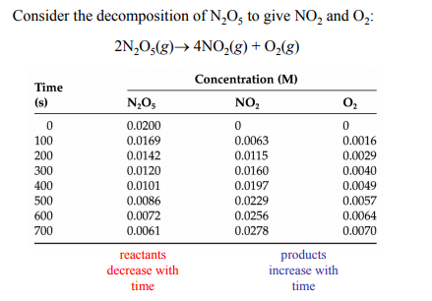
Concentration of Oxygen versus Time for the Decomposition of N₂O₅ Gas

1) Calculate the rate of reaction for oxygen in mol/Ls from 350 s to 525 s.

2) Calculate the rate of reaction for N₂O₅ at 575 s.

3) Calculate the average rate for NO₂ in g/Lmin.

Factors Affecting Reaction Rates

There are 5 important factors that control the rate of chemical reactions:

1) The Nature of the Reactants

Some elements and compounds, because of the bonds broken or formed, react more rapidly with each other

e.g. _______________ vs. ________________.

2) The Concentrations of the Reactants

- increased concentration of dissolved reactants

- and increased pressure of gaseous reactants (decreased volume)

The reaction rate is usually, but not always, proportional to the concentrations of the reactants

e.g. _______________________ vs. _________________________.

3) The Temperature

A temperature increases of 10 ºC above room temperature usually causes the reaction rate to double or triple.

Because ______________________________________________

______________________________________________

4) The Surface Area Exposed

Since most reactions depend on the reactants coming into contact, the surface exposed proportionally affects the rate of reaction

e.g. _________________________________

Because ______________________________________________

______________________________________________

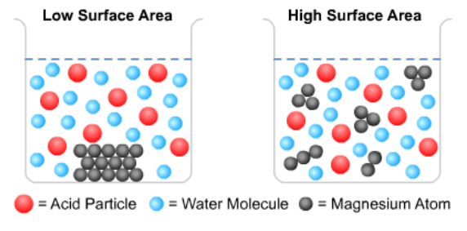

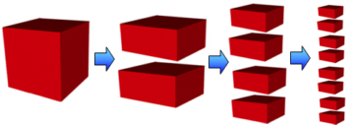

5) The Catalyst

- is a small amount of a substance that speeds up a chemical reaction

- is not consumed by the reaction

- a catalyst can be recovered chemically unchanged at the end of the reaction

- provides a different pathway or series of steps over which the reaction occurs

- lowers the activation energy for the reaction (positive catalyst)

An Inhibitor

- is a small amount of a substance that slows down a chemical reaction

- is not consumed by the reaction

- can be recovered chemically unchanged at the end of the reaction

- it provides a different pathway or series of steps over which the reaction

- raises the activation energy for the reaction (negative catalyst).

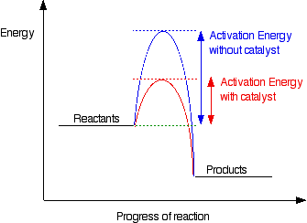

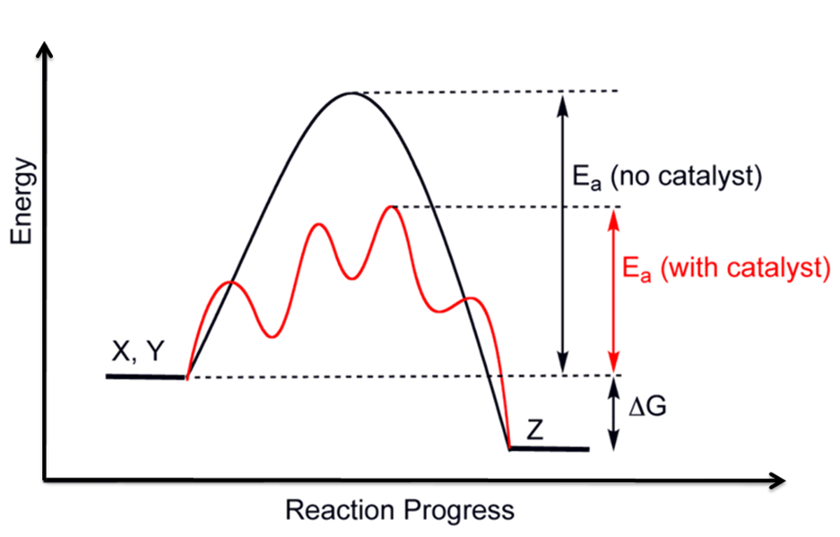

Reaction Mechanism

- the steps of the reaction—how a reaction takes place

- a simple reaction takes place in 1 step -- the reactants collide and become products—this rarely happens!!

- very rarely will 2 As collide with a B to produce a C

- a complex reaction can be broken down into a succession of several simple reactions

- a reaction mechanism is a series of simple reactions that converts reactants into products over the course of a complex reaction

- some steps are fast and some steps are slow

- the slowest step is called the RATE DETERMINING step _______________

- the rate determining step has the highest activation energy

- every step has an activation energy

Experiments have shown that for most reactions the concentrations of all participants change

most rapidly at the beginning of the reaction i.e. the concentration of the ________________

shows the greatest rate of increase and the concentrations of the ______________ show the

highest rate of decrease at this point.

The beginning of a reaction exhibits a linear relationship.

The Nature of Chemical Bonds

Particles which attract each other are in the most stable relative position when they are close to one another i.e. in a state of the lowest possible potential energy. This true of both large and small objects e.g. a ball is attracted to the Earth by the force of gravity is more stable sitting on a beach than high on a hill above the beach.

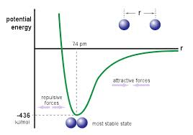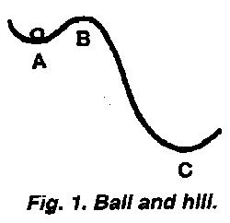

In the realm of the extremely small, it can be said that a proton and an electron which attract each other with the Coulombic Force between oppositely charged particles are more stable when close to one another than when they are far apart. Stability of objects which attract one another is related to the energy of position -- potential energy.

Low potential energy -- high stability -- particles close.

High potential energy -- low stability -- particles far apart.

In nature, when a change occurs which results in a lowering of potential energy (increase of stability), the energy content of the final situation must be lower than that of the beginning situation.

Such a change is exothermic i.e. the energy difference is given off by the system (chemicals) to the surroundings.

e.g. CO₂ formation

When the final energy content is greater than the initial energy content, potential energy increases, the change is endothermic and heat is absorbed from the surroundings.

Experimental evidence shows that energy is always required to break chemical bonds. Conversely, every time a chemical bond forms energy is given off. The process of bond formation is always exothermic. Evidently, chemical bonds form because the atoms are at a lower potential energy and in a more stable condition in the bonded situation than when they are separated.

Fill in the blanks or cross out a word:

The energy of position of 2 bodies relative to each other is called _______________ energy. If 2

bodies that attract each other are far apart, their potential energy is ( high / low ). Low potential

energy is related to ( high / low ) stability. When a chemical bond is formed, energy is always

( released / absorbed ). This is an ( exothermic / endothermic ) process. The average energy

of a C--H bond is 98 kcal per mole of bonds. When a mole of carbon to hydrogen bonds is

broken, 98 kcal are ( released / absorbed ). The formation of chemical bonds involves an

( increase / decrease ) in potential energy and an ( increase / decrease ) in stability.

D.A. Question: If 1 cal = 4.18 J then how many kJ of energy would be absorbed by the breaking of 2.5 moles of C--H?

3 Types of Rates

Initial Rate

- first segment of a concentration versus time graph

- linear segment of the graph = slope = initial rate

Instantaneous Rate

- the rate at any time t

- at time t draw a tangent to the curve

- find the slope of the tangent

Average Rate

- total change over total time

