Radioactivity and Nuclear Energy
Radioactive Atoms
- the nuclei of some U atoms are unstable (Becquerel and Curies)--they give off radioactivity
Radioactivity
Radioactivity | Symbol | Charge | What they are.
Alpha Particles
Beta Particles
Gamma Rays

- unstable nuclei "decay" and emit particles and/or energy = _________ _________ ________

- the nuclei have an unstable ratio of p⁺ to n⁰ -- too many neutrons make the nucleus unstable

- they can be made in the lab (synthesized) but also occur naturally--we are bombarded by radiation all day

- can be very dangerous but also beneficial

- unstable nuclei are called radionuclides or radioisotopes or radioactive isotopes
e.g. tritium H-3 carbon-14 cobalt-60 iodine-131

- radionuclides have half lives--the amount of time before half of a radioactive sample disappears
e.g. Iodine -131 is a radioisotope with a very short half-life of 8.02 days, making it highly radioactive. Frequently used in small doses in thyroid cancers therapies, it is also one of the most feared fission products when accidentally released into the environment.
"If you are treated as an outpatient, family members should not come closer than six feet from you the first day and three feet the second day."
Day 0 Day 8 Day 16 Day 24
100. g of I-131

Applications of Radioactive Isotopes of Elements (radionuclides)
Hydrogen
H-1 = 99.9 % of all H atoms
H-2 = deuterium
H-3 = tritium = radioactive = used in controlled nuclear fusions
Carbon
C-11 for PET scans for brain disorders
C-14 for carbon dating in archeology
C-60
- for aiming at a tumour
- for sterilizing insects
- for destroying parasites in pork and chicken
- for irradiation of strawberries
Iodine
I-131 = killing cancerous thyroid cells
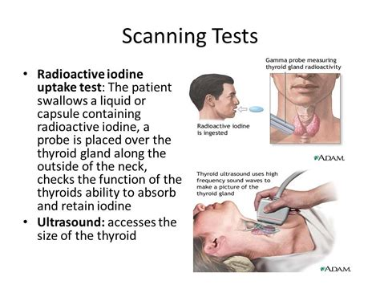

Radiotracers
- tag a molecule with a radioactive atom and follow the radioactivity e.g. blockages in water pipes
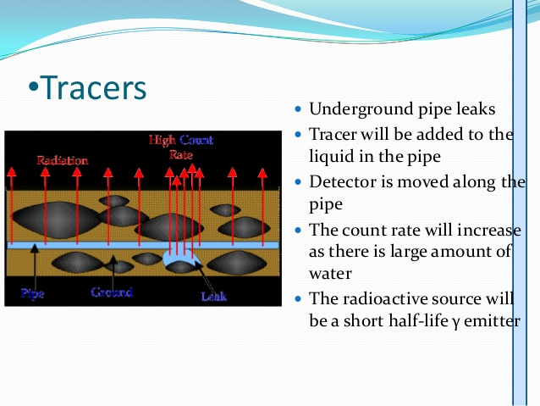

Nuclear Reactors for Energy Production
Advantages
- no GHGs = methane and carbon dioxide

Disadvantages
- disposal of radioactive waste
- cracking of waste containers
- half lives are long therefore stick around for a long time!
- non-renewable--Uranium is found in and mined from rocks

2 Types of Nuclear Reactions
- in a nuclear reaction 1 type of element is changed into another type of element
Fusion
- 2 smaller (lighter) nuclei combine to form a larger more stable nucleus
- huge amount of energy given off = 1 x 10⁶ x a chemical reaction

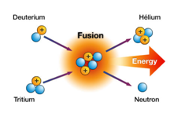 | 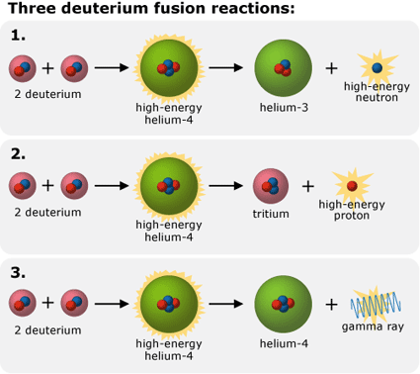

Fission
- bombard a large nucleus with high energy neutrons and split it
- U-235 and Pu-239
- additional neutrons are produced and keep the rxn going = chain rxn
- require a critical mass of material
