Radioactivity and Nuclear Energy
Radioactive Atoms
- the nuclei of some U atoms are unstable (Becquerel and Curies)

- unstable nuclei "decay" and emit particles and/or energy = _________ _________ ________

- the nuclei have an unstable ratio of p⁺ to n⁰ = too many neutrons make the nucleus unstable

- they can be made in the lab but also occur naturally

- can be very dangerous but also beneficial

- are called radionuclides

- have half lives = the amount of time before half of a radioactive sample disappears
e.g.

Applications of Radioactive Isotopes of Elements (radionuclides)
Hydrogen
H-1 = 99.9 % of all H atoms
H-2 = deuterium
H-3 = tritium = radioactive = used in controlled nuclear fusions
Carbon
C-11 for PET scans for brain disorders
C-14 for carbon dating of the age of organic material
Cobalt
C-60
- for aiming at a tumour
- for sterilizing insects
- for destroying parasites in pork and chicken
- for irradiation of strawberries
Iodine
I-131 = killing cancerous thyroid cells
Radiotracers
- tag a molecule with a radioactive atom and follow the radioactivity e.g. blockages in water pipes

Nuclear Reactors for Energy Production
Advantages
- no GHGs = methane and carbon dioxide
Disadvantages
- disposal of radioactive waste
- cracking of waste containers
- half lives are long therefore stick around for a long time!

2 Types of Nuclear Reactions
- in a nuclear reaction 1 type of element is changed into another type of element
Fusion
- 2 smaller (lighter) nuclei combine to form a larger more stable nucleus
- huge amount of energy given off = 1 x 10⁶ x a chemical reaction

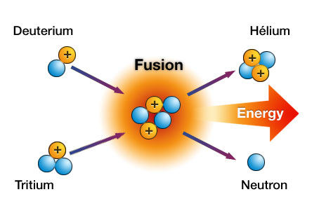

Fission
- bombard a large nucleus with high energy neutrons and split it
- U-235 and Pu-239
- additional neutrons are produced and keep the rxn going = chain rxn
- require a critical mass of material
