Potential Energy Problems
1. Find the potential energy of a light that has a mass of 13.0 kg and is 4.8 m above the ground.
2. An apple in a tree has a gravitational potential energy of 175 J and a mass of 115 g.
How high up is the apple?
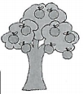

3. A box with a mass of 12.5 kg sits on the floor. How high would you have to lift the box for it to develop a potential energy of 355 J?

4. A marble is on a table 240 cm above the ground. What is the mass of the marble if its potential energy is 568 J?

5.
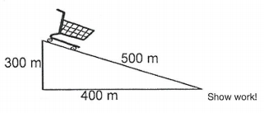
What is the PE of the 6.0 kg cart as it sits at the top of the incline?

What is the Ep of the cart at the bottom of the incline?

6. If a 1.0 x 10⁵ kg jet is flying at height of 35 000 ft what would be its Ep?

http://mrstakash.weebly.com/uploads/5/6/1/2/5612486/pe_and_ke_

