Potential Energy Diagrams Worksheet
Use the following graph to answer the questions below:

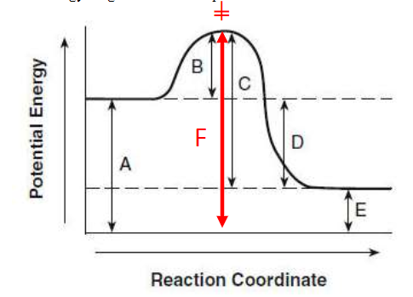

1. Is the above reaction endo or exothermic? ___________
2. Which letter represents the potential energy of the reactants? ___________
3. Which letter represents the potential energy of the products? ___________
4. Which letter represents the heat of reaction? ___________
5. Which letter represents the activation energy of the forward reaction? ___________
6. Which letter represents the activation energy of the reverse reaction? ___________
7. Which letter represents the potential energy of the activated complex? ___________
8. Is the reverse reaction endo or exothermic? ___________

9. Complete the potential energy diagram for an exothermic reaction, where the reactants have 250 kJ of potential energy stored in their chemical bonds, there is 100 kJ of activation energy required and the
Scale and label the y-axis and label the x-axis.

10. Use the diagram below to answer the questions:
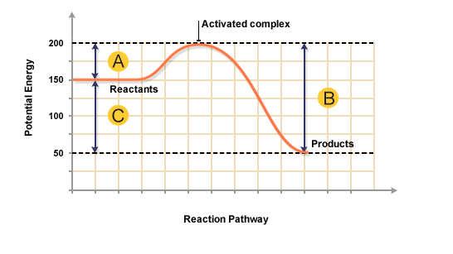
a) The heat content of the reactants of the forward reaction is about ___________kJ.
b) The heat content of the products of the forward reaction is about ___________kJ.
c) The heat content of the activated complex of the forward reaction is about _________kJ.
d) The activation energy of the forward reaction is about ___________kJ.
e) The heat of reaction (∆H) of the forward reaction is about ___________kJ.
f) The forward reaction is _________________________(endo/exo).
g) The heat content of the reactants of the reverse reaction is about __________kJ.
h) The heat content of the products of the reverse reaction is about ___________kJ.
i) The heat content of the activated complex of the reverse reaction is about _________kJ.
j) The activation energy of the reverse reaction is about __________kJ.
k) The heat of reaction (∆H) of the reverse reaction is about ________kJ.
l) The reverse reaction is ______________________ (endo/exo).

11. Given the following ∆H values, write a balanced thermochemical equation:

A) The replacement of iron in thermite, F3₂O₃(s), by aluminum. ∆H = - 852 kJ/mole

B) The formation of calcium hydroxide powder from its elements. ∆H = - 986 kJ/mole

C) The decomposition of water into its elements. ∆H = + 286 kJ/mol H₂O

