Phosphorus--P₄
The two main forms of phosphorus are white phosphorus and red phosphorus.
White phosphorus is a poisonous waxy solid and contact with skin can cause severe burns. It glows in the dark and is spontaneously flammable when exposed to air.
Red phosphorus is an amorphous non-toxic solid.
White phosphorus is used in flares and incendiary devices.

Red phosphorus is in the material stuck on the side of matchboxes, used to strike safety matches against to light them.

By far the largest use of phosphorus compounds is for fertilisers. Ammonium phosphate is made from phosphate ores.

Phosphates are ingredients in some detergents, but are beginning to be phased out in some countries.
This is because they can lead to high phosphate levels in natural water supplies causing unwanted algae to grow.
Biological role
Phosphorus is essential to all living things.
It forms the sugar-phosphate backbone of DNA and RNA.
It is important for energy transfer in cells as part of ATP (adenosine triphosphate), and is found in many other biologically important molecules.
We take in about 1 gram of phosphate a day, and store about 750 grams in our bodies, since our bones and teeth are mainly calcium phosphate.
Over-use of phosphates from fertilisers and detergents can cause them to pollute rivers and lakes causing algae to grow rapidly. The algae block out light stopping further photosynthesis. Oxygen dissolved in the water soon gets used up and the lake dies.

Eutrophication
A major problem with the use of fertilisers occurs when they are washed off the land by rainwater into rivers and lakes.
The resulting increase of nitrate or phosphate in the water encourages algae growth, which forms a bloom over the water surface.
This prevents sunlight reaching other water plants, which then die.
Bacteria break down the dead plants and use up the oxygen in the water so the lake may be left completely lifeless.
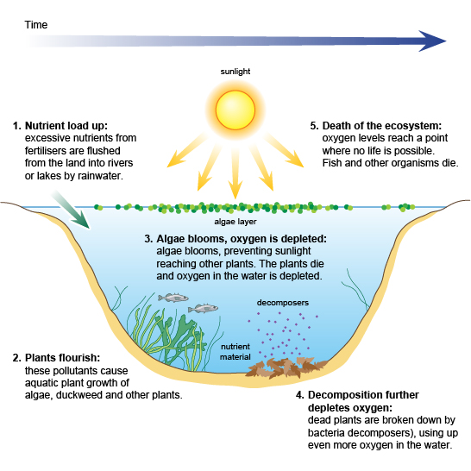
The increase of nitrate or phospate from fertilisers into water causes eutrophication

