pH Scale
You will not be given any of these formulae!!
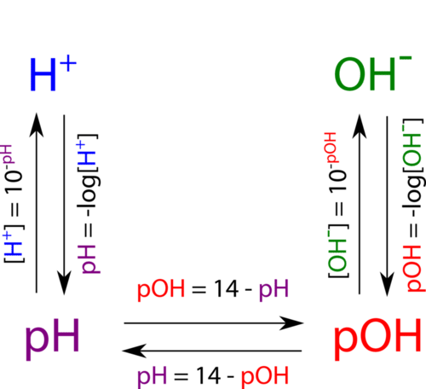
pH = -log [H⁺]
pOH = -log [OH⁻]
pH + pOH = 14
Kw = [H⁺] [OH⁻] = 1 x 10⁻¹⁴

Problems
1) What is the pH of a solution with an H⁺ ion concentration of 1 x 10⁻⁸ M?

2) What is the pOH of a solution with an OH⁻ ion concentration of 1 x 10⁻⁵ mol/L?

3) What is the pOH of a solution with a pH of 9?

4) What is the pH of a solution with a pOH of 3?

5) What happens to the concentration of hydronium ion as you go from pH 5 to pH 2?
M and E!

6) What happens to the concentration of hydroxide ion as you go from pH 10 to pH 8?
M and E!

7) What kind of solution is made by mixing 0.365 g of HCl into a 100.0 mL volumetric flask?

8) What kind of solution is made by mixing 4.00 g of NaOH into a 10.0 L volumetric flask?

9) What happens if 10.0 mL of the solution from 8) is placed into a 1.0 L flask and water is added to the line?

