pH scale comparisons
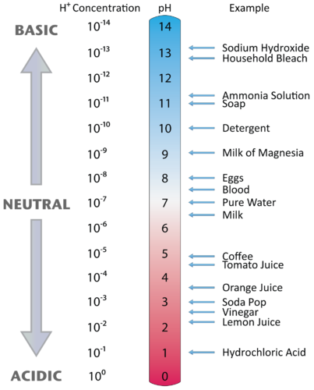
1) What happens to the pH as hydrogen ion concentration increases?
2) What happens to the pH as hydroxide ion concentration decreases?
3) What is the relationship between hydronium ion and hydroxide ion concentrations?
4) How does the pH scale work?

5) What is the difference between a solution with a pH of 6 and a pH of 5?

6) What is the difference between a solution with a pH of 9 and a pH of 11?

