Percent Energy Efficiency

Firstly: Energy is neither created nor destroyed!

But: During energy transformations from electrical energy to useful energy some of the energy is “lost” to useless energy.
In General Lala Land most of the time we live in a frictionless 100 % efficient world.

But even we must deal with the fact that appliances are not 100 % efficient.

Efficiency
- is a measure of how much work or energy is conserved in a process.

- in many processes, work or energy is lost, for example as waste heat or vibration.

- the efficiency is the energy output, divided by the energy input, and expressed as a percentage.

- a perfect process would have an efficiency of 100%.

Percent Energy Efficiency = Energy Output x 100
Energy Input

or = Useful Energy x 100
Consumed Energy

e.g. An electric stand mixer:

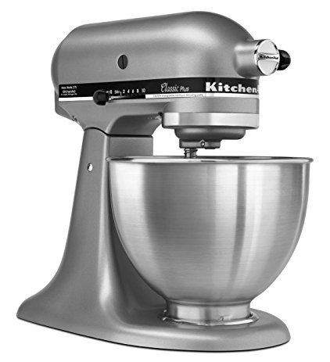
1) A construction worker puts 20.0 J of energy in to one strike of his hammer on the head of a nail. The energy transferred to driving the nail in to the wood is 8.0 J. What is the efficiency of the construction worker's hammering?

What are two possible reasons for the energy loss? _____________________________

2) A particular chemical process has an energy efficiency of only 3.00%.
To complete this large-scale chemical process, 140,000 J of energy is input.
What is the energy output of this process?

http://www.softschools.com/formulas/physics/efficiency_formula/29/

