Percent by Volume Problems % v/v

Volume Percent
- is usually used when the solution is made by mixing two liquids.

- Rubbing alcohol is generally 70% by volume isopropyl alcohol.

- That means that 100 ml of solution contains 70 mL of isopropyl alcohol.

Volume Percent = volume of solute (mL) x 100
volume of solution (mL)

1) What would be the percent by volume of a solution made with 45.0 mL of alcohol with 1 25.0 mL of water? (26.5 % v/v)

2) What would be the concentration in percent volume of a solution made with 67.0 mL of acetone mixed with water to a total volume of 250.0 mL? (26.8 % v/v)

3) How would you make 300.0 mL of a 15 % by volume solution of hydrogen peroxide? (45.0 mL of hydrogen peroxide)

4) What volume of water would be used to make 280.0 mL of a 30. % alcohol solution?
(196 mL of water)

5) A solution is prepared by dissolving 90 milliliters of pure hydrogen peroxide in enough water to make 3000 milliliters of solution.
What is the concentration of the hydrogen peroxide solution? (3.0 % v/v)

6) Binge drinking is considered to be 5 or more drinks on one occasion for a male and 4 or more drinks for a female.
A standard drink is the following:
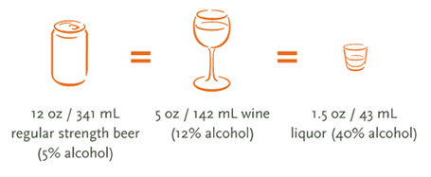
Large wine glasses hold 250.0 mL or 1 cup, which is one third of a bottle of wine.
What is the volume of a standard bottle of wine? _______________
Most wines have an alcohol concentration of 12 % v/v. If a male binge drinks, what volume of alcohol has he consumed?

