Nuclear Chemistry Questions
1) What is fission?
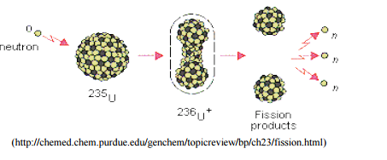

2) What is fusion?
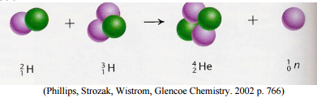

3) What is the difference between deuterium and tritium?

4) During the 1950’s, when many countries performed above ground tests of nuclear weapons, there was much concern about the radioactive fallout when the by-products of uranium fission landed on populated areas. One major concern dealt with the fallout of radioactive strontium isotopes and a suspected link to increases in leukemia and bone cancer. What part of the body might absorb strontium? Explain your answer.

