Naming Binary and Ternary Acids and Their Salts

Ionic ___________________ transfer of electrons therefore _________________

Covalent ___________________ sharing of electrons therefore _________________

Polar Covalent ____________________ but unequal sharing of electrons therefore

To be memorized!

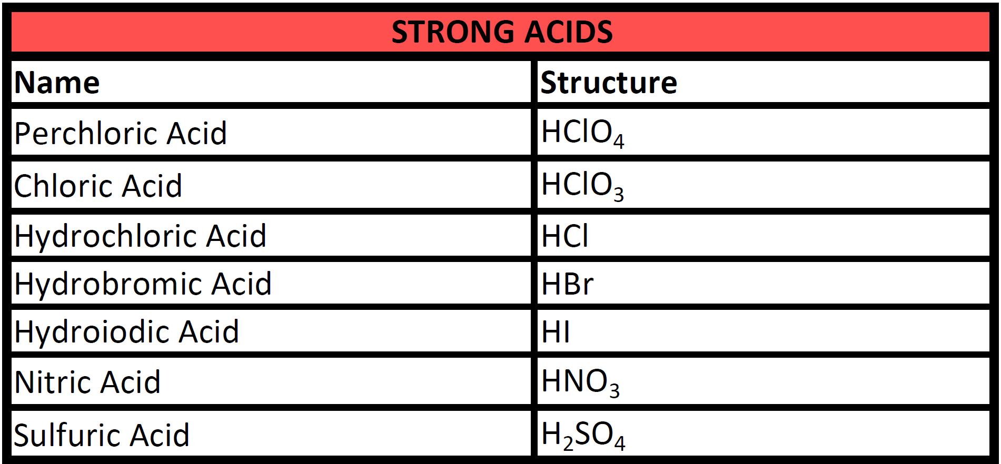

Remember: Acids ____________________________ e.g. ___________________________

To be named as acids hydrogen compounds must be aqueous solutions.
Hydrogen cpds are named as if they were group 1A ionic compounds even
though they are polar covalent compounds.

e.g. HCl(g) is hydrogen chloride and NOT hydrogen monochloride!

e.g. H₂S(g) is _________________________________________

Binary Acids _________________________________________

When the anion does not contain oxygen the acid is a Binary acid.
e.g. HCl, HBr

Use the prefix Hydro plus the root of the anion’s name plus the IC ending—“shorter acid longer name”
e.g. HCl(aq) hydrochloric acid
HBr(aq) hydrobromic acid

Ternary Acids

When the anion contains oxygen it is a Ternary acid—an Oxy-Acid.
Do Not use the prefix hydro!
The name depends on the name of the polyatomic anion.
The name depends on the number of oxygen atoms in the polyatomic ion.

The prefices and suffices are:

ACIDS—H-NM SALTS—M-NM NUMBER OF OXYGENS
PER IC PER ATE 1 MORE OXYGEN
IC ATE STANDARD NUMBER
OUS ITE 1 LESS OXYGEN
HYPO OUS HYPO ITE 2 LESS OXYGEN

You must know the Standard IC oxy-acids by heart before you can start manipulating the prefices and suffices.

e.g. HClO₃ is chloric acid. There are 3 oxygen in the standard IC acid.

