Name: ________________________________________
Partners: ________________________________________
________________________________________

Molar Mass of Butane Gas
http://www.mcvts.net/cms/lib07/NJ01911694/Centricity/Domain/540/Lab%20-%20Butane%20Lab%20Sample%20Calculations.pdf

Purpose: ____________________________________________________________________

Draw the Lewis dot diagram for butane, a hydrocarbon and fuel:

Materials:
- Safety Goggles | - Thermometer
- Big Water Bucket | - Funnel
- Butane Lighter | - 250 mL Graduated Cylinder
- Balance

Procedure:
- Mass the butane lighter.
- Obtain a full bucket of room temperature water.
- Fill the graduated cylinder(gc) to the top with room temperature water
- Invert the gc into the bucket as per the diagram:
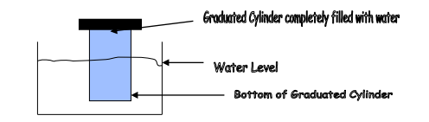
- Place funnel underneath the gc.
- One person continues to hold the gc so it does not tip over.
- Place the butane lighter underneath the water and beneath the funnel:
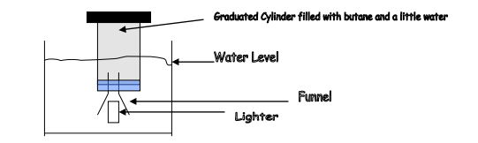

- Release gas until 150. to 200. mL of gas have been collected by pressing on the lever.
- Put a glass square under the gc and bring it to the front of the class and place it in the fish tank.
- Lift the gc up until the level of the water in the gc is level with the water level in the tank.
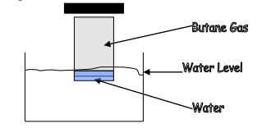
What is the reason you have to do this step?

__________________________________________________________________

__________________________________________________________________
- Record the volume of butane in the gc.
- Shake out the butane lighter and dry it—do not touch the release lever!!!!!
- Mass the dry butane lighter.

Data Table: Molar Mass of Butane Gas Data

Analysis:
1. The butane gas you collected in the gc was "wet". Why is this the case?

____________________________________________________________________________

2. There is a vapour pressure chart at the front of the class.
Determine the pressure of “dry” butane gas: _________________

3. Determine the moles of butane collected: _________________

3. Determine the experimental molar mass of butane gas: _________________

4. Determine the percent error: _________________

Conclusion: __________________________________________________________________

__________________________________________________________________

Questions:

1. Explain why you made the water level inside the gc the same as the water level in the bucket.

____________________________________________________________________________

____________________________________________________________________________

2. Why were you asked to find the pressure of “dry” gas?

____________________________________________________________________________

____________________________________________________________________________

3. What were the sources of error and do not write human error!

____________________________________________________________________________

____________________________________________________________________________

