Molar Enthalpy—Change in Enthalpy—(Molar) Heat of Reaction--∆H

Enthalpy ___________________________________________________________________

All changes involve a certain amount of heat energy being absorbed and released.

The difference between the amount absorbed and released determines whether the change is endothermic or exothermic.

Molar Enthalpy _______________________________________________________________

Endothermic | Exothermic
- System gains energy  - Surroundings lose energy  - Surroundings feel cooler  - ΔH is positive  - Energy value on left of equation (reactant)  - Potential energy increases | - System loses energy  - Surroundings gain energy  - Surroundings feel warmer  - ΔH is negative  - Energy value on right of equation (product)  - Potential energy decreases

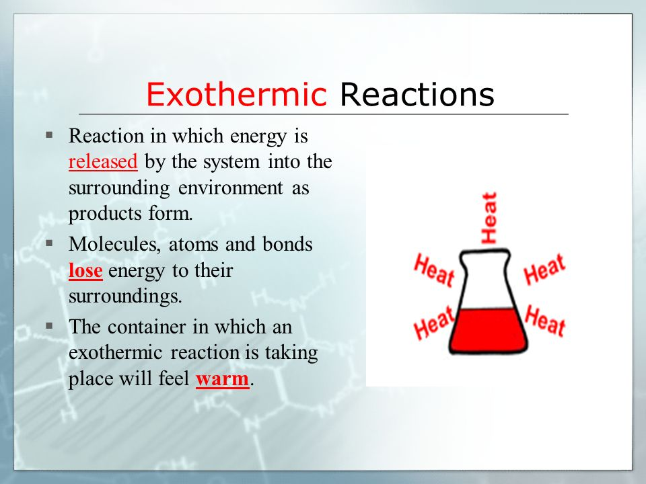

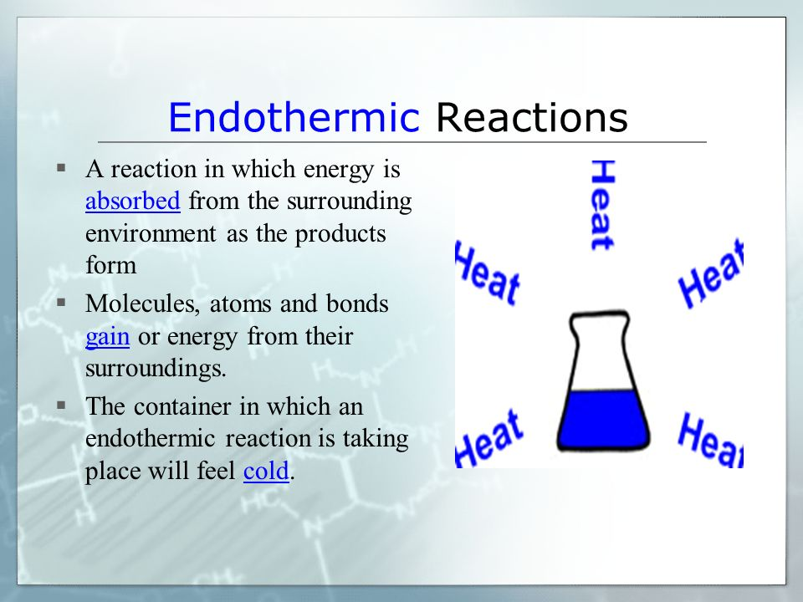

Enthalpy Changes

All chemical bonds have stored or potential energy.
Whenever the bonds in molecules (chemical change) OR between molecules (physical)
change, there is a change in the potential energy.

Enthalpy changes

- Enthalpy can change during a physical change, a chemical change or in a nuclear reaction.
∆H physical changes ‹ ∆H chemical changes ‹ ‹ ‹ ∆H nuclear reactions

Physical changes:
1) Phase Changes or Changes of State
The bonds between molecules are broken or formed (intermolecular forces).

Solid Liquid Gas

**During a phase change the ________________________________ does not change!
Therefore, you cannot use Q=mc∆T as ∆T would be __________________________ which
would mean the amount of heat energy required to undergo the phase change would be
_________________.

What to do??????????????????

2) Dissolution (Dissolving)
- when a solute dissolves into a solvent to form a solution
- the solution process is very complicated--the solute particles must separate from each, the solvent particles must separate from each other, the solute and solvent must mix and the solute and solvent interact
- molar enthalpies of solution can be endo or exo
- lower enthalpy or EXO is a driving force but endo ones still dissolve!!
- ENTROPY or randomness is also a driving force--the drive towards chaos
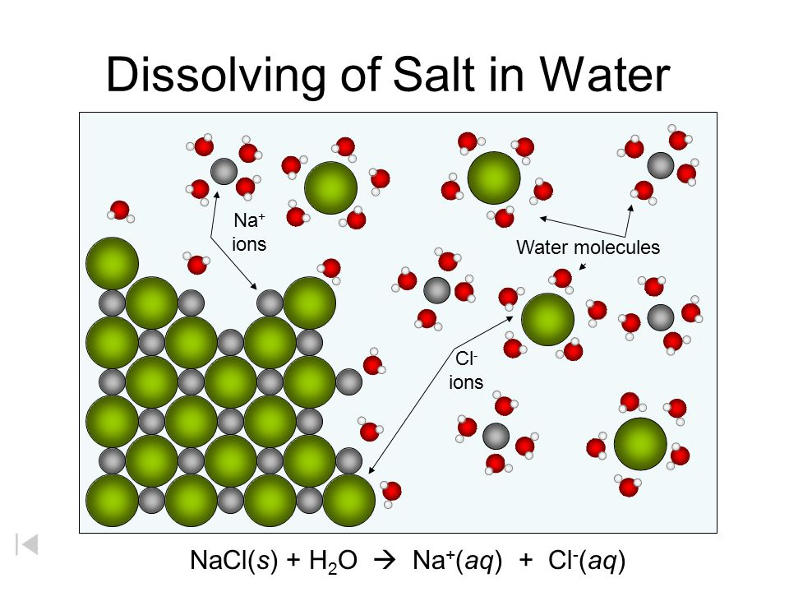

Chemical reactions:
Ionic and covalent bonds break and new ones form (intra-molecular forces).
The products have a different amount of potential energy because the bonds are different.

Nuclear reactions: Bonds between particles in the nucleus are broken.

Very often, the enthalpy change is known for common reactions and phase changes.
The amount of the substance is important to the energy change.
Chemists use moles to describe the amount of a substance.
The energy change is given as molar enthalpy (ΔH).

Molar enthalpy (ΔH):
The enthalpy change of 1.0 mol of a substance undergoing a change.
The units are given as kilojoules per mole (kJ/mol).

Symbol | Process Represented | Change
ΔH_{comb} | Heat of combustion | chemical
***ΔH_{f} | Heat of formation | chemical
ΔH_{r} | Heat of a reaction | chemical
ΔH_{fus} | Heat of fusion (melting) | physical
ΔH_{vap} | Heat of vaporization | physical
ΔH_{solid (fre)} | Heat of solidification (freezing) | physical
ΔH_{cond} | Heat of condensation | physical
ΔH_{sol} | Heat of solution (dissolving) | physcial

***Formation Reaction
Element + Element + Element → 1 mol of Compound

Calorimetry

- is used to measure to enthalpy of a reaction (also called heat of a reaction).

- It measures energy changes using an isolated system, a thermometer and a known mass of water.

- The simplest calorimeter is just two Styrofoam cups with a lid.

The isolated system does not allow energy to pass in or out.
Therefore, all of the energy from the physical or chemical change, gets absorbed by the water.
Or the water releases energy if the process is endothermic.
Several assumptions are made when using calorimeters:
1. No heat is transferred between the calorimeter and the outside environment
2. Any heat absorbed or releases by the calorimeter materials is negligible
3. A dilute aqueous solution has the same density and specific heat capacity as pure water

Where do you stick the thermometer????

