Mixing Problems with Ksp
To predict the possibility of a precipitate forming during a chemical reaction:
Knowing the solubility product of a salt, it is possible to predict whether, on mixing the solution of its ions, a ppt will form or not.
For precipitation to occur, its ionic product or Ktrial should exceed the Ksp value or solubility product constant.
If the ion concentrations in the mixture are too high a ppt will form.
If the ion concentrations are low enough, even if an “insoluble” salt could form and ppt out—it will not!!
Thus:
If the Ion Product is greater than the Ksp value a ppt occurs.
e.g. Kidney Stones: are actual stones that form in your body!!
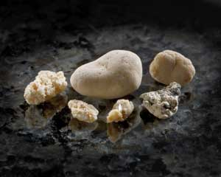
Today, up to 12% of men and 5% of women will develop at least one kidney stone by age 70. Recurrence rates are estimated to be as high as 50%, giving credence to the old adage "once a stone former, always a stone former."
Most stones occur when calcium combines with one of two substances: oxalate or phosphorous. Stones can also form from uric acid, which forms as the body metabolizes protein.
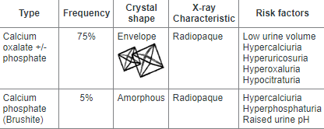
e.g. Gout: a type of arthritis in which small crystals form inside and around the joints.
It causes sudden attacks of severe pain and swelling.
The condition mainly affects men over 30 and women after menopause. Overall, gout is more common in men than women.
If you produce too much uric acid or your kidneys don't filter enough out, it can build up and cause tiny sharp crystals to form in and around joints. These crystals can cause the joint to become inflamed (red and swollen) and painful.
Can be caused by the under-excretion of urate, the salts of uric acid by your kidneys.
Dietary causes account for about 12% of gout,^{[3]} and include a strong association with the consumption of alcohol, fructose-sweetened drinks, meat, and seafood.

If the Ion Product is less than the Ksp value a ppt will not occur.

