Mixing Problems I

1a.
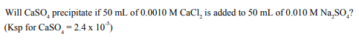

1b.

2.
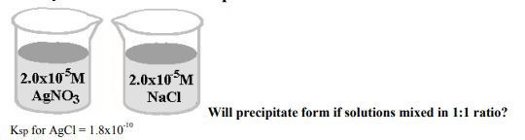

3.

4.

5.

