The Height of a Tree
Purpose
- To determine the height of a tree without climbing it!!
Materials
- Paper plate
- Straw
- Protractor
- Washer
- Scotch tape
- Measuring tape
- Clipboard
Procedure
1) Make a paper plate clinometer.

This is a device that relies on trigonometry.
A simple model can be made with a paper plate, a straw, some string and a weight (washer).
Cut the plate in half and glue a straw along the cut edge.
This is a sighting guide.
Exactly half way along the cut plate edge stick a piece of string with a weight on the end so that it dangles beyond the edge of the plate.

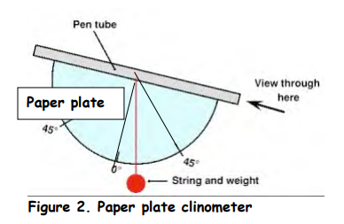

You now need to be able to find the line that is 45 º to the straw.
If there is a pattern of crenulations along the outer curved edge of the plate it may be possible to calculate this position.
Count the crinkles and locate the middle one.
A line from here to where the string is attached will be 0 º.
A position exactly half way between 0 º and the cut edge of the plate is 45 º.
Alternatively use a protractor (in fact the clinometer can be made using a protractor to replace the paper plate).

2) Labeled sketch of what you will do outside—go big or go home—big enough to show your work!

Answer: _________________________

Conclusion

____________________________________________________________________________

____________________________________________________________________________

