Measuring Gas Pressure

Barometer Manometer

Barometer
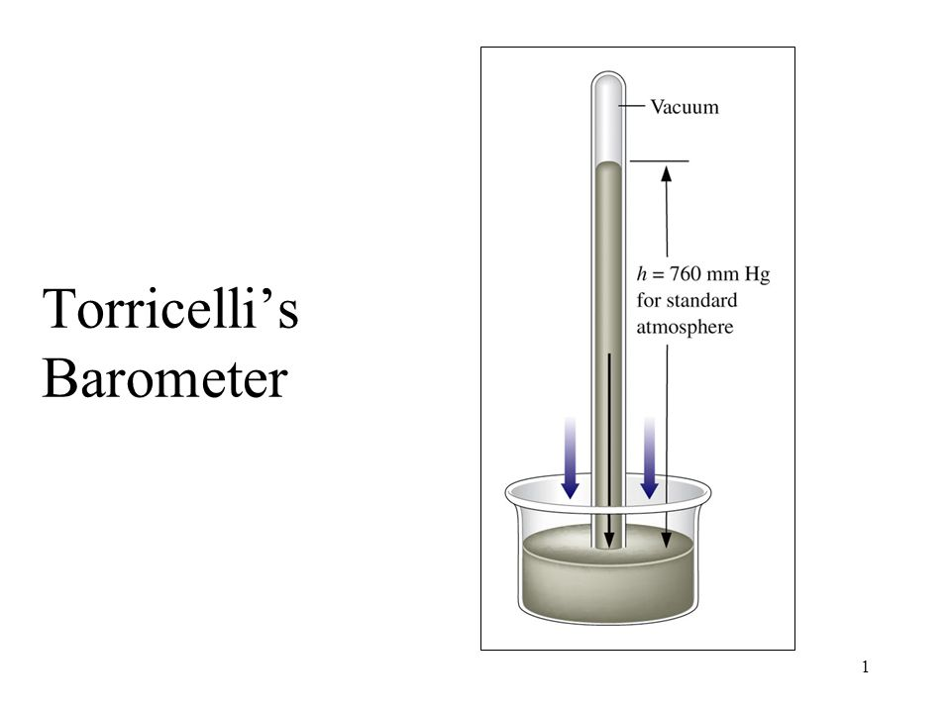

Manometer 1) Open-ended
2) Close-ended

Open-ended Case 1 Case 2
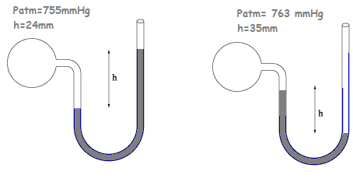

Close-ended
