Maxwell-Boltzmann Distribution Curves

What is the Maxwell-Boltzmann distribution?
The air molecules surrounding us are not all traveling at the same speed, even if the air is all at a single temperature. Some of the air molecules will be moving extremely fast, some will be moving with moderate speeds, and some of the air molecules will hardly be moving at all. Because of this, we can't ask questions like "What is the speed of an air molecule in a gas?" since a molecule in a gas could have any one of a huge number of possible speeds.
So instead of asking about any one particular gas molecule, we ask questions like, "What is the distribution of speeds in a gas at a certain temperature?" In the mid to late 1800s, James Clerk Maxwell and Ludwig Boltzmann figured out the answer to this question. Their result is referred to as the Maxwell-Boltzmann distribution , because it shows how the speeds of molecules are distributed for an ideal gas. The Maxwell-Boltzmann distribution is often represented with the following graph:

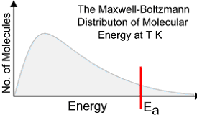

The y-axis of the Maxwell-Boltzmann graph can be thought of as giving the number of molecules per unit speed. So, if the graph is higher in a given region, it means that there are more gas molecules moving with those speeds.

Addition of Reactant (Increase in Concentration)

Removal of Reactant (Decrease in Concentration)

Increase in Temperature

Decrease in Temperature

Addition of a Catalyst

Addition of an Inhibitor

