Magnetism Questions
1. Circle the ferromagnetic materials i.e. the materials that can be attracted by a magnet:
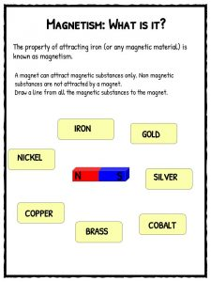
2. Sketch the magnetic field lines between the magnets:
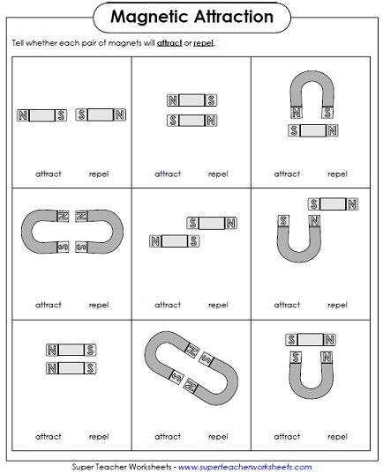
3. What happens when you bring a compass near a magnet? How does it depend on where you place the compass?

4. Draw the magnetic field around the two magnets below:

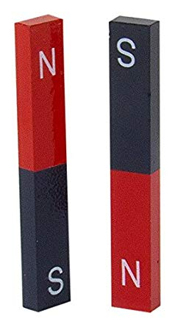

5. Explain what this diagram is showing:
