The Ksp of Calcium Hydroxide

Purpose
- to determine the Ksp for limewater, aqueous calcium hydroxide

Substances are considered insoluble if they cannot be dissolved to form a solution of ≥
____________ concentration.

Formula of calcium hydroxide: ____________________________

Ms. Purcell and Ms. Wardrop have prepared a saturated soln of calcium hydroxide.

Label the sketch of what this would look like:
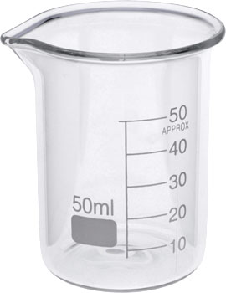

What does the saturated calcium hydroxide soln at the front bench in the burets look like?
___________________________________

Why? What did they do?

____________________________________________________________________________

Materials:
- buret with calcium hydroxide at the front bench
- ring stand
- buret clamp
- buret
- hydrochloric acid--concentration _____________________
- Erlenmeyer
- BTB (bromothymol blue) dropper bottle
- white square of paper

Procedure:
- obtain 10.00 mL of unknown concentration of calcium hydroxide saturated soln in Erlenmeyer
- add 5 drops of BTB--dropping--no touching!
- add hydrochloric acid to the buret at your bench
- place Erlenmeyer under buret
- place paper under Erlenmeyer
- add HCl with 2 hands on stopcock
- swirl Erlenmeyer after each addition
- titrate solution until a shade of white zinfandel

BCE for the reaction taking place in the Erlenmeyer

____________________________________________________________________________

What is the point of doing the titration?

____________________________________________________________________________

____________________________________________________________________________

Observations:

Calculations:

Ionic dissociation equation for calcium hydroxide:

____________________________________________________________________________

Ksp Expression:

Ksp = ___________________

Conclusion: ________________________________________________________________

Questions
1) What is the difference between an endpoint and an equivalence point?
____________________________________________________________________________
____________________________________________________________________________

2) Is calcium hydroxide soluble? How do you know? Explain.
____________________________________________________________________________
____________________________________________________________________________
____________________________________________________________________________

