Ionic Dissociation and Ksp (the equilibrium constant for a saturated soln)

A Saturated Soln is an equilibrium situation.
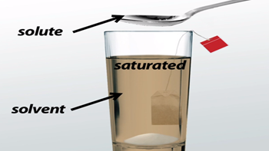

- Even though it is an open beaker the equilibrium is between the solid at the bottom and the dissolved particles in solution.

- The rate of the _____________________________________________ is equal to the rate of

______________________________________________________________________.

We will be dealing only with ionic compounds (salts or bases) dissolved in solution.

Ionic compounds not only _________________________ they _________________________.

Write the dissociation equations for the following salts:

BaCl₂(s) _______________________________________________________________

Cu(NO₃)₂(s) _______________________________________________________________

(NH₄)₃PO₄(s) _______________________________________________________________

The solubility product constant is called the Ksp.

It is the Keq or Kc for a specific instance i.e. a saturated solution of an ionic compound.

It indicates the max concentrations of ions that can be present in solution before a residue forms (or a ppt—more on this later).

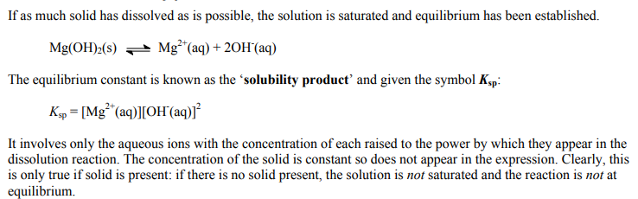

Recall how to write equilibrium expressions—what is included and what is not for a Kc or Keq!

Write the Ksp for the 3 previous salts:

Ksp for barium chloride:

Ksp for copper (II) nitrate:

Ksp for ammonium phosphate:

1) Watch Crash Course Chemistry 9 Video Precipitation Reactions
2) Watch Golden Rain Video
3) Work on equilibrium packages – you have a test on Thursday April 19th.

