Name: ________________________ Date: _____________________

Introduction to Energy Efficiency

A Light bulb has the ability to transform electrical energy into two types of energy. What are they?

_____________________________________
_____________________________________

Which type of energy can be considered as “useful” energy for the purpose of a light bulb?
___________________________________

The mathematical unit for measuring energy is the _____________________.

Suppose 100J was supplied to the light bulb below from the wire, and each block of energy provided represents 10J of energy.

Draw the following situations:

- A light bulb that is 10% efficient:
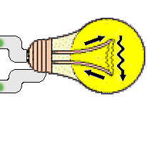
Heat (Thermal energy)
Electrical Energy

Light (Radiant energy)

- A light bulb that is 50% efficient:

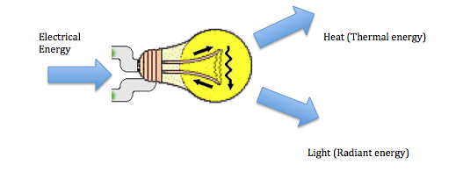
- A light bulb that is 90% efficient:

- A light bulb for which 20% of the energy is lost to the environment:
What would the energy efficiency be in this case?

