How do Acid Base Indicators Work
Acid Base indicators themselves act as acids or bases--by releasing or adding a proton--H⁺.

BTB
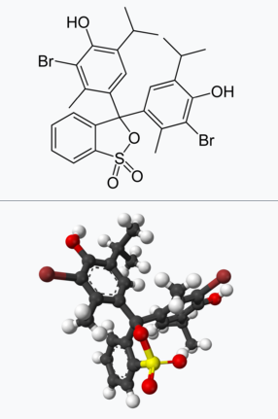 | 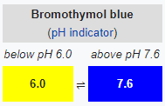

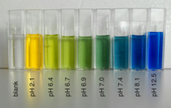

What we see as ``colour``
Color is the aspect of things that is caused by differing qualities of light being reflected or emitted by them.
To see color, you have to have light. When light shines on an object some colors bounce off the object and others are absorbed by it. Our eyes only see the colors that are bounced off or reflected.
The colour of light reflected depends on the shape of the molecules!

