How a “Ding Ding” Doorbell Works

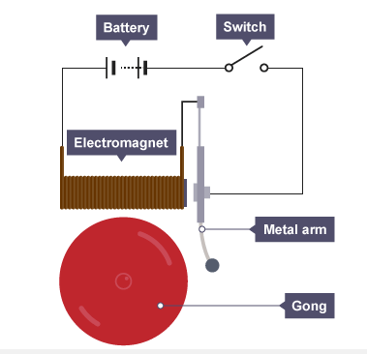
Justify how this doorbell is a “ding ding” doorbell and not just a “ding” doorbell. Use point form to explain the steps of how this doorbell rings and what the various parts must be made of and how they function.

