Hot and Cold Hands Demo
Necessary Info:
Temperature is a measure of ___________________________________________________
____________________________________________________________________________

Definition of Heat Energy ______________________________________________________
___________________________________________________________________________

What is 40 ºF in ºC? ºF = ºC x 9/5 + 32

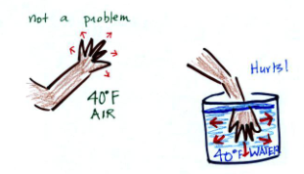
Why? ______________________________________________________________________
____________________________________________________________________________

How are the molecules of water moving in the cold water vs. the hot water?

____________________________________________________________________________

When you add energy to an object and the object warms, what exactly is happening inside the object?

____________________________________________________________________________

Touch the wood--Touch the metal Demo

What is the temperature of the wood? _____________________
What is the temperature of the metal? _____________________
How does the wood feel? _____________________
How does the metal feel? _____________________

Explain ________________________________________________________________
____________________________________________________________________________

Hot water--Cold water Demo

1 Fill one bowl with ice water--one with room temperature water--and one with hot water.

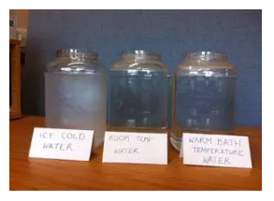

2 Put your left hand into the hot water and the right hand into the ice water for one minute.

3 Take your hands out of the water--shake--and put them both into the room temperature water.

How does your left hand feel? _________________________

How does your right hand feel? _________________________

Explain: __________________________________________________________

______________________________________________________________________

