Heating and Cooling Curves

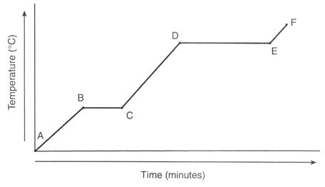

Kinetic Energy

Potential Energy

