“4 Step” ∆H Problems

1) Q water = m of water x c of water x change in temperature of the water

- The thermometer was stuck in the ______________________________

- The water is the ___________________________________________

- The water gives us information about the _______________________

2) Q substance = - Q water

- Whatever happens to the water is the _________________________ of what

happens to the ______________________________

- Assuming _____________________________ efficiency of energy transfer

3) n of substance i) grams of substance to moles of substance using ____________

ii) mL of a solution x concentration of the solution _____________

4) ∆H of substance = ________________________________

Therefore the order is:
i) Q water
ii) Q sub = - Q water
iii) n sub
iv) ∆H
e.g. Calculating ∆Hcomb of Methanol
Student Data--should be recorded in a data table!!
Ti = 22.0 ºC
Tf = 55.0 ºC
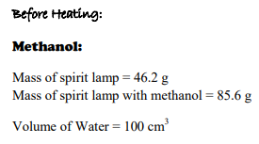
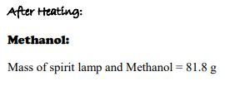

But … if you can calculate steps i) to iv) you can do the reverse and start with the ∆H and work backwards to the initial or final temperature of the water!!
This means in a word problem you had better be able to identify if you are dealing with:
- the water (surroundings) or the system

- heat energy Q or a molar enthalpy ∆H
List your givens just like in math class!

Reverse 4 Step Problem
Lithium chloride dissolves in water according to the following equation:

_________________________________________________________ ∆H = - 35.0 kJ/mol

If 8.42 g of lithium chloride are dissolved in 200. mL of water at 22.0 ºC, what will be the final temperature of the water?

