EST Ecotoxicology Notes 1
https://www.youtube.com/watch?v=v6ubvEJ3KGM
Food Web
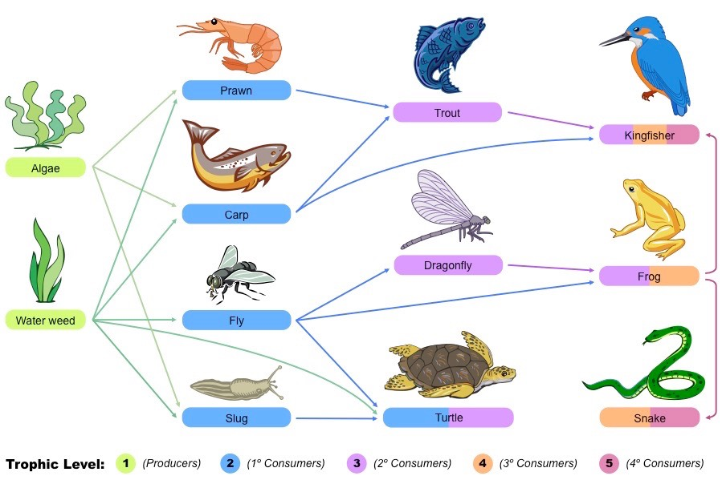

Defn of a Food Chain___________________________________________________________________

What starts all food chains? ______________________________________________________________

What does the word PRODUCER mean? __________________________________________________

What does the word CONSUMER mean? __________________________________________________

Food Chain Examples:
e.g. with a secondary consumer ________________________________________________________

e.g. with a ternary consumer ________________________________________________________

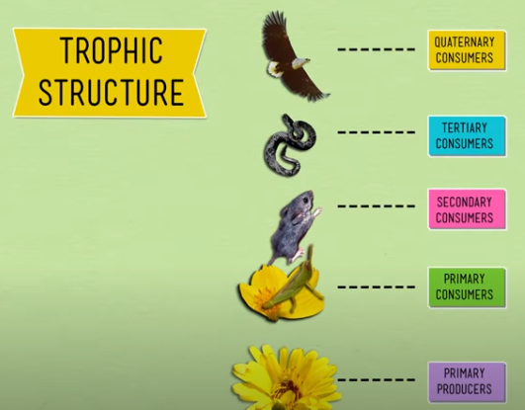

What does QUATERNARY mean? _______________________________________________________

What is a? TROPHIC LEVEL? _______________________________________________________

Defn of a Food Web __________________________________________________________________

What is the source of all energy for any ecosystem? _____________________________________

How is that energy incorporated into a food chain? _____________________________________

Equation (BCE) for the chemical reaction that takes place using energy from the sun:

____________________________________________________________________________________
___________________ → __________________ → _________________→ ___________________

